

MediNurse

## Medical Website

Senior Project By

**Ahmad Makki**

### Submitted to the School of Arts & Science of the Lebanese International University

In part of fulfillment of the requirements for the degree of

**BACHERLOR OF SCIENCE IN**

**COMPUTER SCIENCE AND INFORMATION TECHNOLOGY**

**Supervised by: Dr. Haissam El-Aawar**

### Spring 2024

Dedication:

First of all, we will dedicate this project to our almighty God, who gave us strength and knowledge for our everyday life.

To our beloved parents and friends, for always supporting us in our studying and work, and for helping us find and realize our potential.

Last to our respected professor Haissam El-Aawar for leading us step by step to reach our aim and to overcome every single obstacle we faced during the time we worked on our project.

**Acknowledgment:**

We have really worked hard and put so many efforts in our "MediNurse" project. However, it would neither have been completed on time nor looked like we wanted without the kind and special support of some individuals and organizations. We would like to extend our sincere thanks to all of them.

We are highly indebted to our professor Haissam El-Aawar for his guidance and constant supervision as well as for providing necessary information regarding our project.

My thanks and appreciations also go to our parents and friends for their encouragement that helps us finish our project perfectly and on time.

**Abstract:**

This report introduces a web-based platform tailored to bridge the communication gap between patients and private nurses, aimed at optimizing the delivery of medical services. The platform offers an intuitive interface allowing patients to effortlessly request medical assistance, schedule appointments, and engage in real-time communication with private nurses. Leveraging modern web technologies and robust security measures, the website ensures the confidentiality of patient information and compliance with regulatory standards. By facilitating seamless interaction and streamlining appointment scheduling, the platform not only improves accessibility to healthcare services but also enhances patient experience and promotes proactive health management.

In summary, this project represents a significant stride in healthcare technology, offering a scalable solution to enhance patient-nurse connectivity and optimize resource utilization in the medical care domain. Through its user-friendly interface and comprehensive functionalities, the website stands poised to revolutionize the way patients access medical care and interact with private nurses, fostering a more efficient and patient-centric healthcare ecosystem.

# List of Tables:

Table 1: sign up use case 18

Table 2: sign in use case 18

Table 3: choose nurse use case 18

Table 4: request appointment use case 19

Table 5: request service use case 19

Table 6: Subscribe to insurance plan use case 19

Table 7: comment to blog use case 19

Table 8: apply as nurse use case 20

Table 9: sign in use case 20

Table 10: Manage appointments use case 20

Table 11: Manage requests of services use case 20

Table 12: Manage availabilities use case 21

Table 13: Manage services use case 21

Table 14: sign in use case 21

Table 15: manage blogs use case 22

Table 16: manage insurance plans use case 22

Table 17: Manage nurse applications use case 22

Table 18: Manage subscriptions use case 22

List of Figures:

Figure 1: Use case diagram for admin – patient 16

Figure 2: Use case diagram for nurse – patient 17

Figure 3: Use case diagram for admin – nurse 17

Figure 4: Relational Model 24

Figure 5: home page 27

Figure 6: sign up page 28

Figure 7: sign in page 28

Figure 8: apply as nurse page 29

Figure 9: home page of admin 29

Figure 10: nurses page 30

Figure 11: nurse details page 30

Figure 12: patients page 31

Figure 13: upcoming applications page 31

Figure 14: applications page 32

Figure 15: blogs page 33

Figure 16: blog details page 33

Figure 17: comments page 33

Figure 18: insurance plans page 34

Figure 19: subscribers page 34

Figure 20: edit plan page 35

Figure 21: home page of patients 35

Figure 22: find nurse page 36

Figure 23: nurse details page 36

Figure 24: request appointment page 37

Figure 25: request service page 37

Figure 26: insurance plan page 38

Figure 27: insurance plan details page 38

Figure 28: blogs page 39

Figure 29: blog details page 40

Figure 30: appointments requested page 40

Figure 31: requested services page 41

Figure 32: home page of nurse 41

Figure 33: requested appointments 42

Figure 34: appointment details 42

Figure 35: upcoming requests for services 43

Figure 36: requested services details 43

Figure 37: availabilities page 44

Figure 38: services page 44

Contents

Chapter 1 11

1.1-Introduction: 11

1.2-Objective: 11

1.4 -Technology Constraints: 12

1.5-Problem: 13

1.6-Solution: 13

Chapter 2 14

2.1-Functional and Conceptual Study 14

2.2-UML Use Case Diagram & Scenario: 15

Chapter 3 23

3.1-System Design: 23

Chapter 4 25

Implementation: 25

Chapter 5 45

5.1 Conclusion: 45

5.2 Future Work: 45

References 46

### Chapter 1

In this chapter, we are going to state the problem that we find, and how our project helps in solving it, in addition to mentioning technology constraints and our objective, then explaining all of them in details.

### 1.1-Introduction:

### In the landscape of modern healthcare, effective communication between patients and healthcare providers is fundamental to ensuring timely and comprehensive medical care. However, traditional methods of patient-nurse interaction often suffer from inefficiencies such as long waiting times, limited accessibility, and cumbersome appointment scheduling processes. To address these challenges, this report introduces a novel web-based platform designed to facilitate seamless communication between patients and private nurses. By leveraging the power of digital technology, this platform aims to revolutionize the way patients access medical services, empowering them to request assistance, schedule appointments, and engage in real-time communication with private nurses from the comfort of their homes. [1]

### This innovative solution not only enhances the accessibility and convenience of medical care but also fosters a more collaborative and patient-centric approach to healthcare delivery. With its user-friendly interface and robust backend infrastructure, the platform is poised to streamline the entire process of patient-nurse interaction, ultimately improving patient outcomes and promoting proactive health management. Through this introduction of advanced digital tools into the healthcare landscape, this project signifies a significant advancement in medical technology, promising to reshape the future of patient care delivery and redefine the patient-nurse relationship. [2] [3]

### 1.2-Objective:

Improve Accessibility: The primary objective of this project is to enhance the accessibility of medical services by providing patients with a user-friendly platform to connect with private nurses.

Optimize Appointment Scheduling: The project seeks to optimize the appointment scheduling process by implementing an integrated scheduling system.

Ensure Security and Compliance: Ensuring the security and confidentiality of patient information is paramount.

Enhance Patient Experience: Ultimately, the overarching objective is to enhance the overall patient experience by offering a seamless and convenient platform for accessing medical services.

Provide patients by insurance plan to help them subscribe and be always in safe side.

1.3-Scope:

The scope of this project encompasses the development of a user-friendly website connecting patients with private nurses, enabling seamless communication and appointment scheduling. Key features include nurse profile management, patient registration and profile creation, and the implementation of a secure messaging system. The platform will allow nurses to manage their profiles, set availability, and communicate with patients, while patients can register, create profiles, browse nurse profiles, and request appointments. The website will prioritize user experience, security, and compliance with regulatory standards, aiming to enhance accessibility to medical services and streamline the patient-nurse interaction process.

### 1.4 -Technology Constraints:

**Software needed:** Visual studio code, Xampp, Web browser

**Languages:** php, javascript, html, css, mysql

**Frameworks & libraries:** bootstarp

**Hardware:** laptop.

### 1.5-Problem:

Without the proposed website, several challenges may impede the efficiency and accessibility of patient-nurse communication and medical service delivery:

1. Limited Access to Qualified Nurses.
2. Disjointed Communication Channels.
3. Difficulty in Tracking and Managing Patient-Nurse Interactions.
4. Manual and Time-Consuming Appointment Scheduling.

### 1.6-Solution:

Creating an online website that will help nurses and patients in:

* Finding qualified and nearest nurses.
* Centralized Communication and Appointment Scheduling
* Enhanced Nurse Visibility and Availability
* Helping nurses to find jobs.
* Request nurse to some small medical services.
* Request private nurses for some days.

### Chapter 2

This chapter describes both functional and non-functional requirements for our project. In addition to that it shows the UML use cases and scenarios with all related details.

### 2.1-Functional and Conceptual Study

#### 2.1.1-Functional Requirements:

**Sign up:** Every person can view the home page but only registered people who have an account can profit from website services.

**Login:** The system allows patients and nurses to login easily to view their own dashboard using their email and password.

**Apply as Nurse:** the system allows new nurses to send a join application for admin.

**Find Nurses**: Patients can see all nurses joined with their personal, contact, education and experience information.

**Request appointments and services:** The system allows patients to request appointments and services from nurses that they prefer with knowing prices.

**Subscribe to insurance plan:** The system allows patients to subscribe to one or more medical insurance plan to save his life or his patient’s life with a yearly or monthly subscriptions.

**Follow up the latest medical news:** The system allows patients to read medical and scientist blogs and interact with them by leaving their comments.

**Manage requests and scheduling of nurses:** The system allows nurses to manage their availabilities and services that they offer by determining prices of each one.

**Accept only qualified nurses:** admin accept nurses according to their experience and education so that he can accept qualified ones and reject others.

#### 2.1.2-Nonfunctional requirements:

* **Security**: The website must encrypt sensitive data and protect against cyber threats.
* **Performance**:
  + Fast Response Time for User Login (The average response time for user login after entering email and password should be no more than 3 secs and the maximum response time should be 10 seconds),
  + Fast Average Time for Rendering a Page (After clicking on any link the result should be rendered within no more than 1 second in average and it should not take more than 10 seconds in maximum),
  + Minimum number of concurrent users: The website should be able to address at least 1000 users concurrently.
  + If any internet problem takes place, a loading page will be opened to inform the user about his connecting problem.
* **Usability**: Interface should be intuitive and accessible on various devices.
* **Reliability**:
  + Availability: The system is available all the time (24*7 available).
* **Interoperability**: Ability to integrate with other healthcare systems and technologies.
* **Maintainability**:
  + Well-documented codebase for future updates and enhancements.
  + Errors: The system will track every mistake. [4]

### 2.2-UML Use Case Diagram & Scenario:

#### 2.2.1-Use Case Diagram

**Patient** [actor](https://www.uml-diagrams.org/use-case-actor.html) uses our website to request appointment and medical services. Top level [use cases](https://www.uml-diagrams.org/use-case.html) are **Browse, Login, Find nurses, subscribe to insurance plans, view blogs and comment, and view requests**.

**Sign up** use case is included in login.

For the **Admin and Nurse** actors there are several use cases which will be discussed below with details. [5]

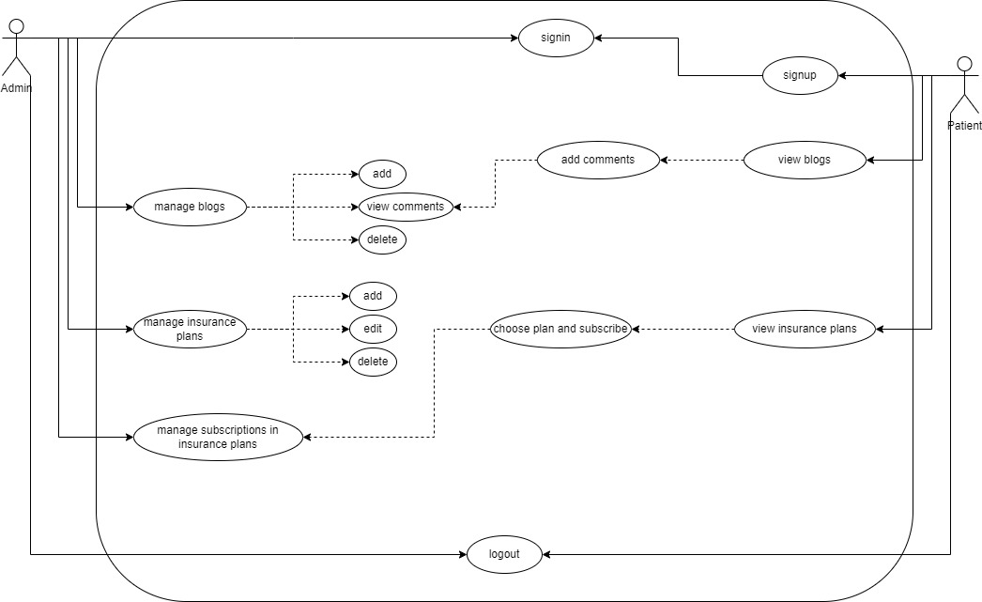

Figure : Use case diagram for admin – patient

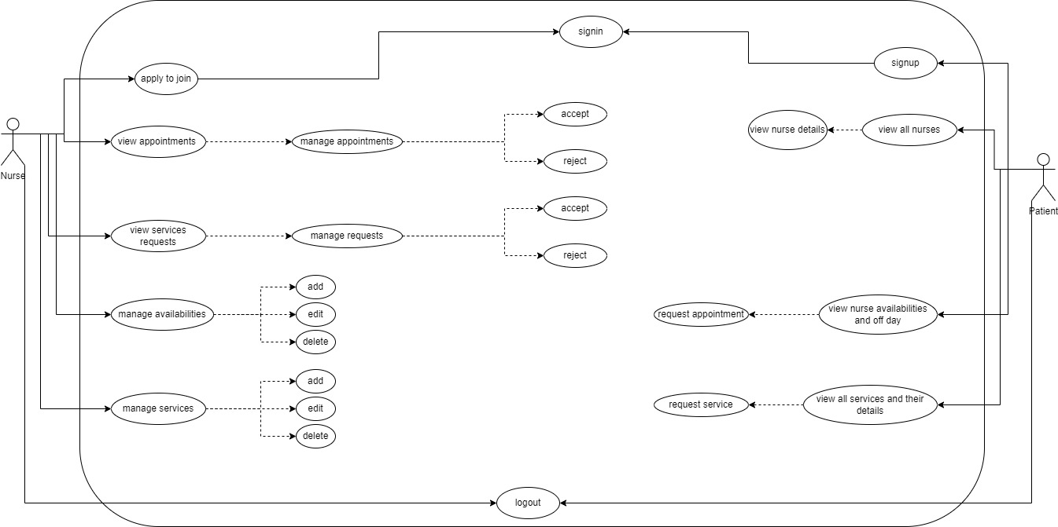

Figure : Use case diagram for nurse – patient

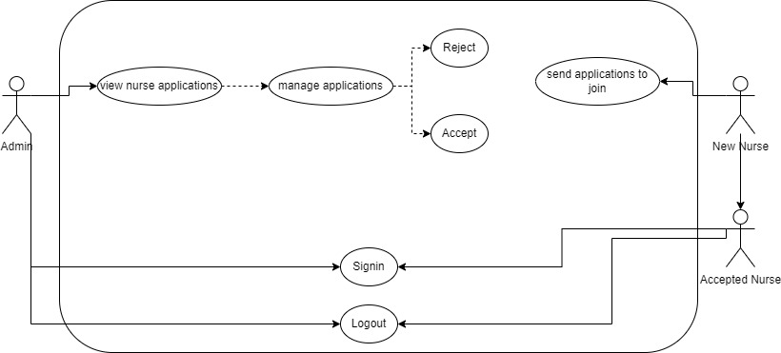

Figure : Use case diagram for admin – nurse

#### 2.2.2-Use Case scenarios (patient actor)

|  |  |
| --- | --- |
| **Use case Name** | **Sign up** |
| Actors | New patient |
| Brief description | New patient should create new account |
| Basic flow | Create new account |
| Alternative flow | Login if already has account |
| Pre-conditions | None |
| Post-conditions | Personal information, phone number and confirmed password |

Table : sign up use case

|  |  |
| --- | --- |
| **Use case Name** | **Sign in** |
| Actors | patient |
| Brief description | patient can access his dashboard by logging in correctly |
| Basic flow | Login form |
| Alternative flow | None |
| Pre-conditions | Already registered |
| Post-conditions | Phone number and password correctly |

Table : sign in use case

|  |  |
| --- | --- |
| **Use case Name** | **Choose nurse** |
| Actors | Patient |
| Brief description | Patient can see all available nurses and see all details related to each nurse.  He can view nurse’s personal and contact info, his availabilities, his off days and all services that a nurse offers. |
| Basic flow | Nurses page |
| Alternative flow | Request appointment  Request service |
| Pre-conditions | None |
| Post-conditions | nurseID |

Table : choose nurse use case

|  |  |
| --- | --- |
| **Use case Name** | **Request appointment** |
| Actors | Patient |
| Brief description | Patient can request appointment from a nurse. |
| Basic flow | Request appointment page |
| Alternative flow | Nurses page |
| Pre-conditions | nurseID  patientID  availabiltyID |
| Post-conditions | appointmentID |

Table : request appointment use case

|  |  |
| --- | --- |
| **Use case Name** | **Request service** |
| Actors | Patient |
| Brief description | Patient can request service from a nurse. |
| Basic flow | Request service page |
| Alternative flow | Nurses page |
| Pre-conditions | nurseID  patientID  serviceID |
| Post-conditions | requestID |

Table : request service use case

|  |  |
| --- | --- |
| **Use case Name** | **Subscribe to insurance plan** |
| Actors | Patient |
| Brief description | Patient can choose an insurance plan and subscribe to it. |
| Basic flow | Subscribe page |
| Alternative flow | Insurance plans page |
| Pre-conditions | planID  patientID |
| Post-conditions | subscriptionID |

Table : Subscribe to insurance plan use case

|  |  |
| --- | --- |
| **Use case Name** | **Comment to blogs** |
| Actors | Patient |
| Brief description | Patient can read blogs and interact with them by adding his opinion as comments. |
| Basic flow | blogs page |
| Alternative flow | None |
| Pre-conditions | blogID |
| Post-conditions | commentID  patientID |

Table : comment to blog use case

#### 2.2.3-Use Case scenarios (nurse actor)

|  |  |
| --- | --- |
| **Use case Name** | **Apply as a nurse** |
| Actors | New nurse |
| Brief description | New patient should send an application for admin to join the team |
| Basic flow | Apply as a nurse |
| Alternative flow | Login if already has account |
| Pre-conditions | None |
| Post-conditions | Personal information, contact information, education and experience info and confirmed password |

Table : apply as nurse use case

|  |  |
| --- | --- |
| **Use case Name** | **Sign in** |
| Actors | Nurse |
| Brief description | Nurse can access his dashboard by logging in correctly |
| Basic flow | Login form |
| Alternative flow | None |
| Pre-conditions | Already accepted by the admin |
| Post-conditions | Email and password correctly |

Table : sign in use case

|  |  |
| --- | --- |
| **Use case Name** | **Manage appointments** |
| Actors | Nurse |
| Brief description | Nurse receives upcoming appointments and manages them by accepting or rejecting them. |
| Basic flow | Appointments |
| Alternative flow | None |
| Pre-conditions | Accept or reject: appointmentID |
| Post-conditions | appointmentID |

Table : Manage appointments use case

|  |  |
| --- | --- |
| **Use case Name** | **Manage requests of services** |
| Actors | Nurse |
| Brief description | Nurse receives upcoming services’ requests and manages them by accepting or rejecting them. |
| Basic flow | Requests of services |
| Alternative flow | None |
| Pre-conditions | Accept or reject: requestID |
| Post-conditions | requestID |

Table : Manage requests of services use case

|  |  |
| --- | --- |
| **Use case Name** | **Manage availabilities** |
| Actors | Nurse |
| Brief description | Nurse manage his availabilities by adding new availability or by updating and deleting existing ones. |
| Basic flow | Manage Availabilities |
| Alternative flow | None |
| Pre-conditions | Add: none  Update: availabilityID  Delete: availabilityID |
| Post-conditions | None |

Table : Manage availabilities use case

|  |  |
| --- | --- |
| **Use case Name** | **Manage services** |
| Actors | Nurse |
| Brief description | Nurse manage the services that he/she offers by adding new service or by updating and deleting existing ones. |
| Basic flow | Manage services |
| Alternative flow | None |
| Pre-conditions | Add: none  Update: serviceID  Delete: serviceID |
| Post-conditions | None |

Table : Manage services use case

#### 2.2.4-Use Case scenarios (admin actor)

|  |  |
| --- | --- |
| **Use case Name** | **Sign in** |
| Actors | Admin |
| Brief description | Admin can access his dashboard by logging in correctly |
| Basic flow | Login form |
| Alternative flow | None |
| Pre-conditions | Email and password |
| Post-conditions | None |

Table : sign in use case

|  |  |
| --- | --- |
| **Use case Name** | **Manage blogs** |
| Actors | Admin |
| Brief description | Admin manage blogs by adding new blogs, update or delete existing one.  Blogs are the medical news, medical trends, new medicine … |
| Basic flow | blogs page |
| Alternative flow | None |
| Pre-conditions | Add blog: none  Update blog: blogID  Delete blog: blogID |
| Post-conditions | None |

Table : manage blogs use case

|  |  |
| --- | --- |
| **Use case Name** | **Manage insurance plans** |
| Actors | Admin |
| Brief description | Admin manage insurance plans by adding new plans, update or delete existing one.  Insurance plan are a plan to help people in healthy and medical insurance by a monthly or yearly subscription in a plan. |
| Basic flow | Insurance plan page |
| Alternative flow | None |
| Pre-conditions | Add Insurance plan: none  Update Insurance plan: planD  Delete Insurance plan: planID |
| Post-conditions | None |

Table : manage insurance plans use case

|  |  |
| --- | --- |
| **Use case Name** | **Manage nurse applications** |
| Actors | Admin |
| Brief description | Admin receives nurse applications from new nurses, then accept or reject nurse.  By accepting nurse admin creates new nurse |
| Basic flow | Nurse applications page |
| Alternative flow | None |
| Pre-conditions | Accept nurse: applicationID  Reject nurse: applicationID |
| Post-conditions | Accepted nurse: nurseID |

Table : Manage nurse applications use case

|  |  |
| --- | --- |
| **Use case Name** | **Manage subscriptions** |
| Actors | Admin |
| Brief description | Admin receives subscriptions in insurance plans from users. |
| Basic flow | subscriptions page |
| Alternative flow | None |
| Pre-conditions | patientID  planID |
| Post-conditions | None |

Table : Manage subscriptions use case

### Chapter 3

This chapter describes the system design, including the data base of our project, the related tables and the relations between them.

### 3.1-System Design:

#### 3.1.1-ER-Diagram

This ER (Entity Relationship) Diagram represents the model of nurse to patient communication system. It shows all the instruments of database tables and the relations between them.

The main entities of this project are: admin, appointments, availability, blogs, comments, insurance_plans, nurses, nurse_applications, patients, services, service_requests, subscriptions

Entities and their attributes:

* Admin (**adminID**, email, password)
* Patients (**patientID**, first_name, last_name, address, phone, gender, birthdate, password)
* Nurses (**nurseID**, first_name, last_name, gender, birthdate, profile, address, email, phone, password, certificate, college, years_of_experience, skills)
* Nurse_applications (**applicationID**, first_name, last_name, gender, birthdate, profile, address, email, phone, password, certificate, college, years_of_experience, skills)
* Blogs ( **blogID**, title, details, date_of_publish, category, image)
* Insurance_plans (planID, name, description, image, yearly_price, monthly_price)
* Services (**serviceID**, name, description, price, #nurseID)
* Availabilities ( **availabilityID**, day, work_time, price_per_hour, #nurseID)
* Appointments (**appointmentID**, date, coming_time, status, #nurseID, #patientID, #availabilityID)
* Service_requests (**requestID**, date, time, status, #nurseID, #patientID, #serviceID)
* Subscription (**subscriptionID**, price_method, payment_method, #planID, #patientID)
* Comments (**commentID**, comment, date, #blogID, #patientID)

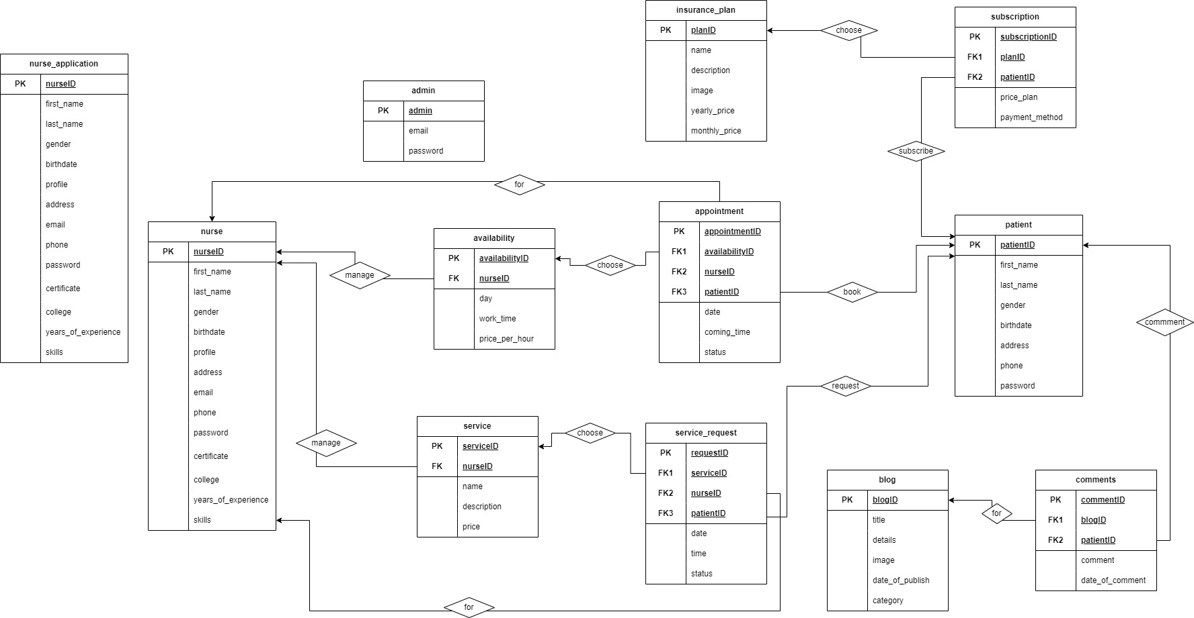

Figure : Relational Model

### Chapter 4

This chapter describes the whole view of our website, it shows the design our projects in addition to stating the main role of each page or button.

### Implementation:

#### 4.1-Introduction:

The implementation of our online medical care system simply show how the interface of this system will look like and how it is applied in order to ensure good performance and service for the customer, our aim is to create a simple interface that is almost suitable for all ages, we tried our best to make it as simple as possible and comfortable for the eyes. It is enough for the user to enter our website and then he/ she can easily flow from page to page without any difficulty or interruptions.

Below we are going to view different pages of our website and how they are going to be in details.

4.2- Project’s Parts:

4.2.1-Home page:

It consists of 5 sections that are:

Menu and main background of welcome.

About us section

Services section

Apply as a nurse section

Footer section

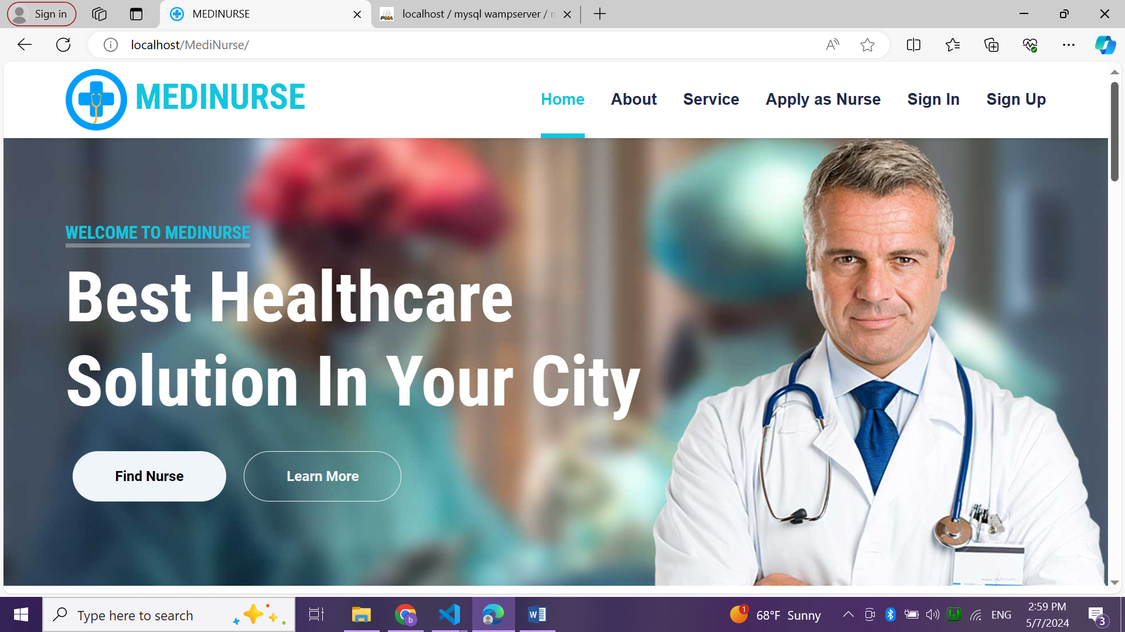

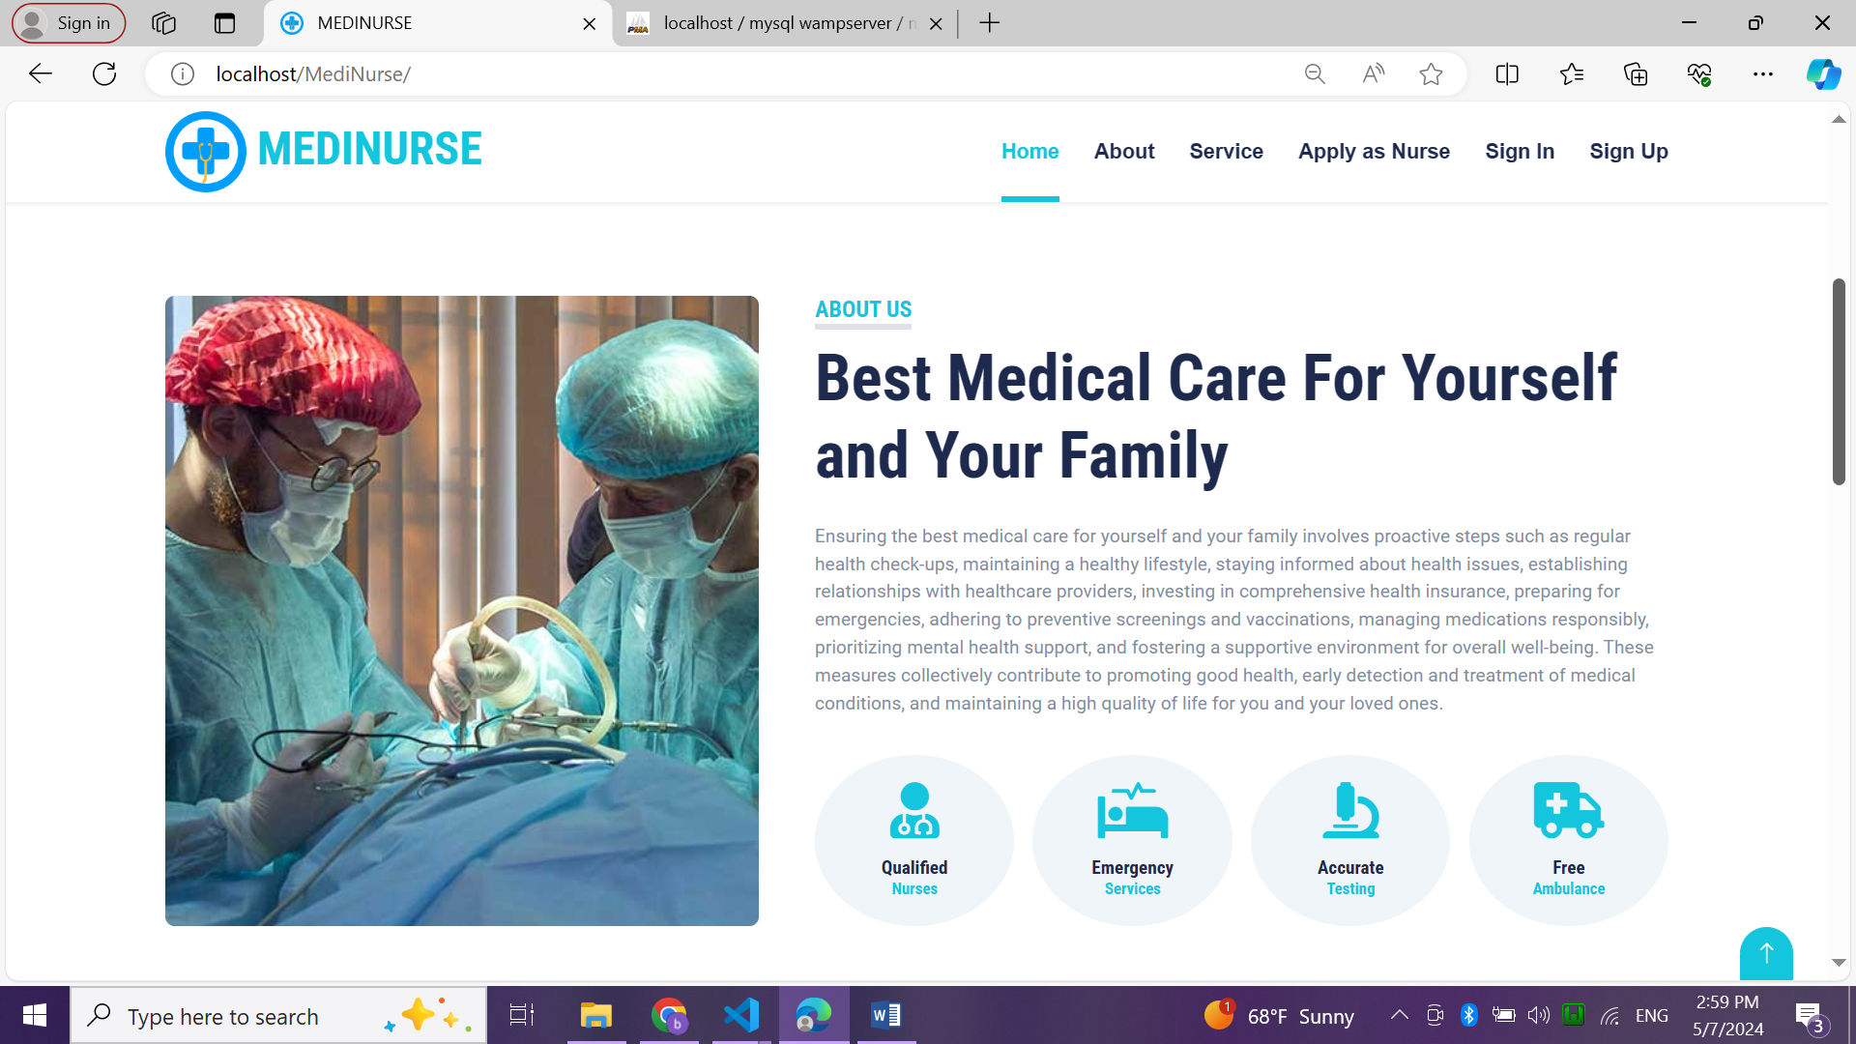

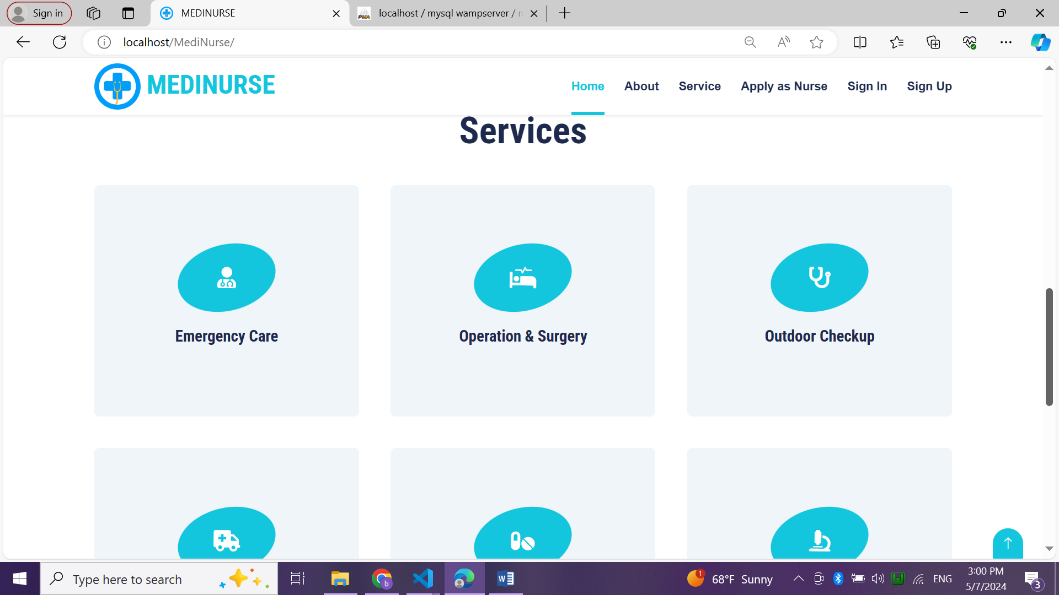

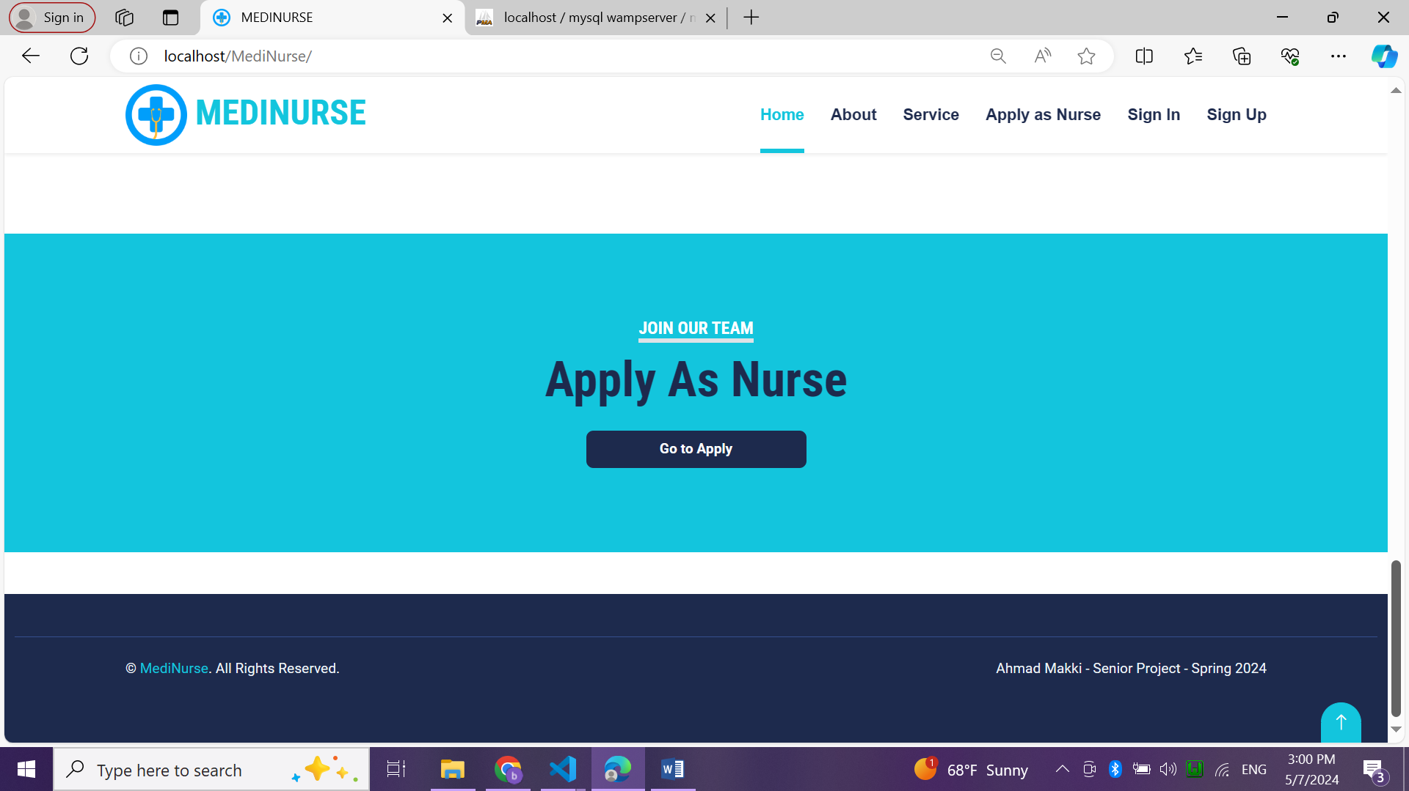

Figure : home page

4.2.2. sign up page

New patients should create new account by filling the registration form by their personal information.

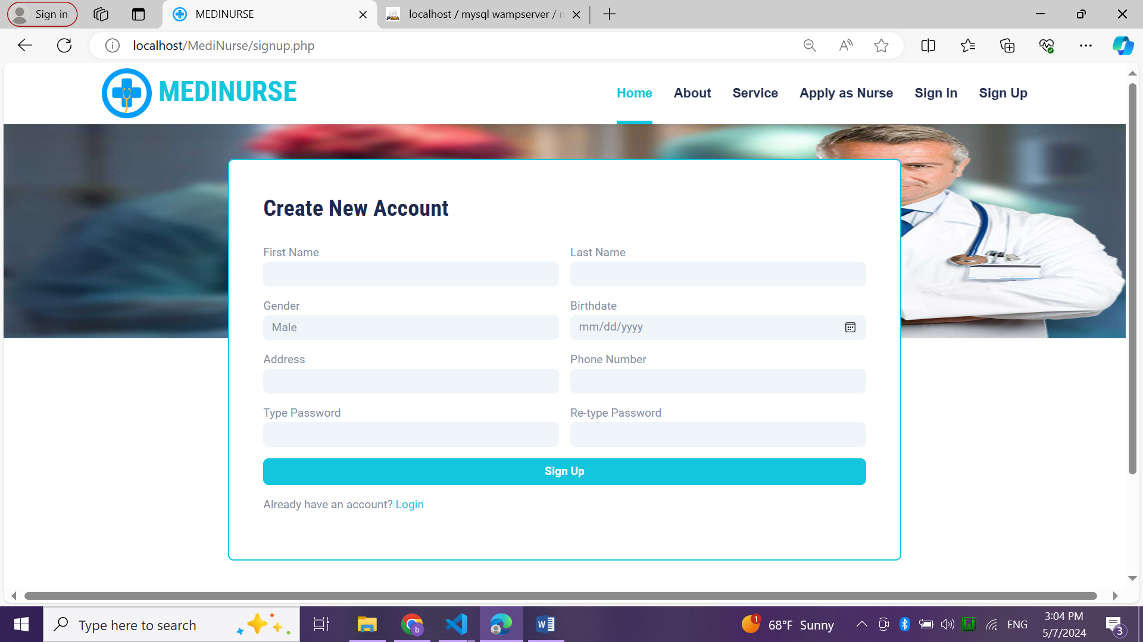

Figure : sign up page

4.2.3. Sign in page

In sign-in page, patient, nurse and admin should enter their email and password to login.

In wrong email or password case, an alert appear with this error.

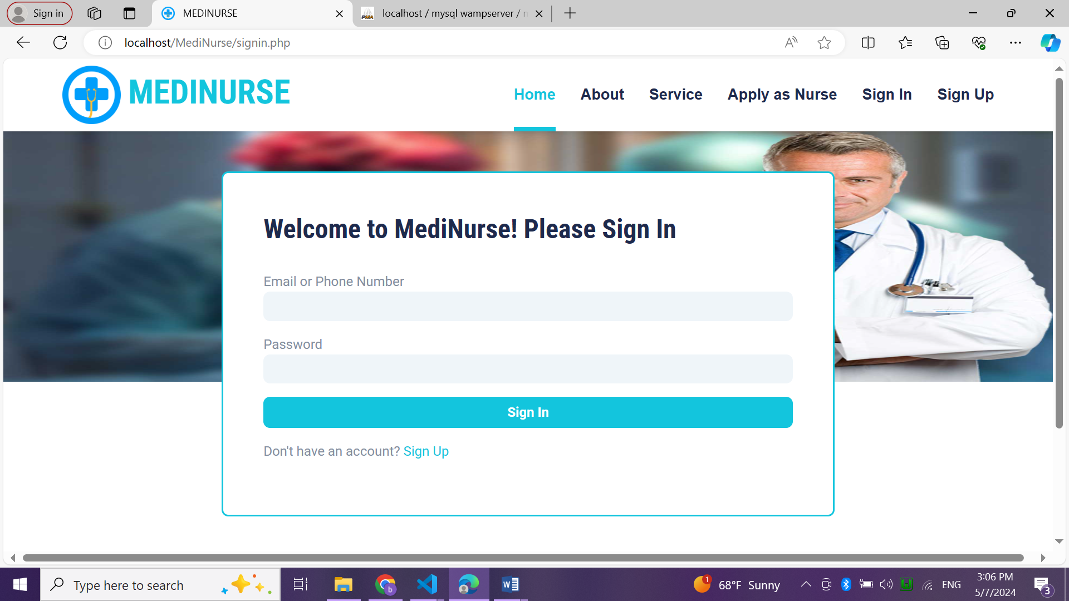

Figure : sign in page

4.2.4. apply as nurse page

In this page, new nurses should fill this form by their personal, contact, education and experience info to send a join application to the admin.

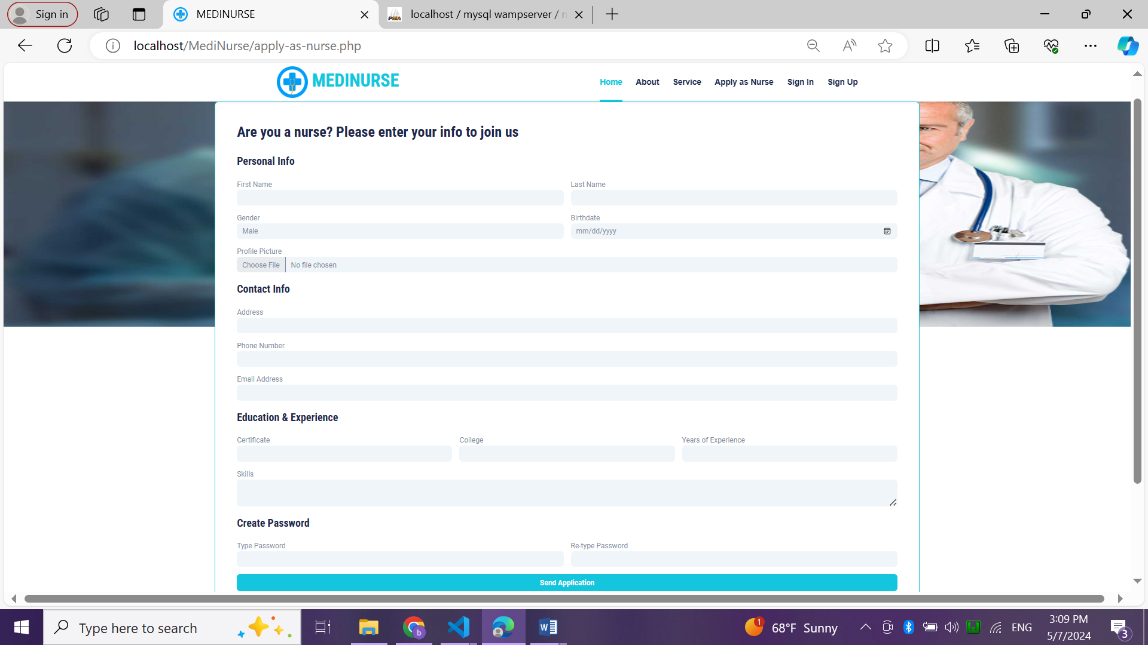

Figure : apply as nurse page

4.2.5. home page of admin

It is a menu for admin and one background to welcome admin.

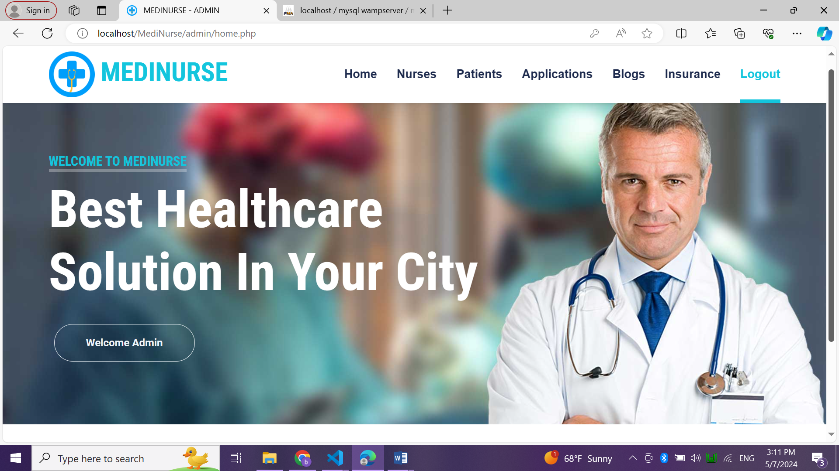

Figure : home page of admin

4.2.6. Nurses page

This page shows all nurses joined and accepted by admin with their information and button to view all their details.

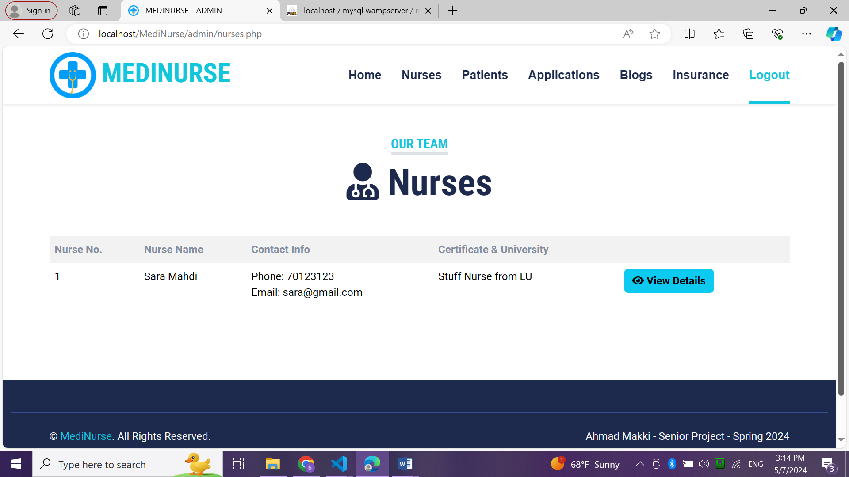

Figure : nurses page

4.2.7. nurse details page

This page shows all details related to a nurse with his/her profile.

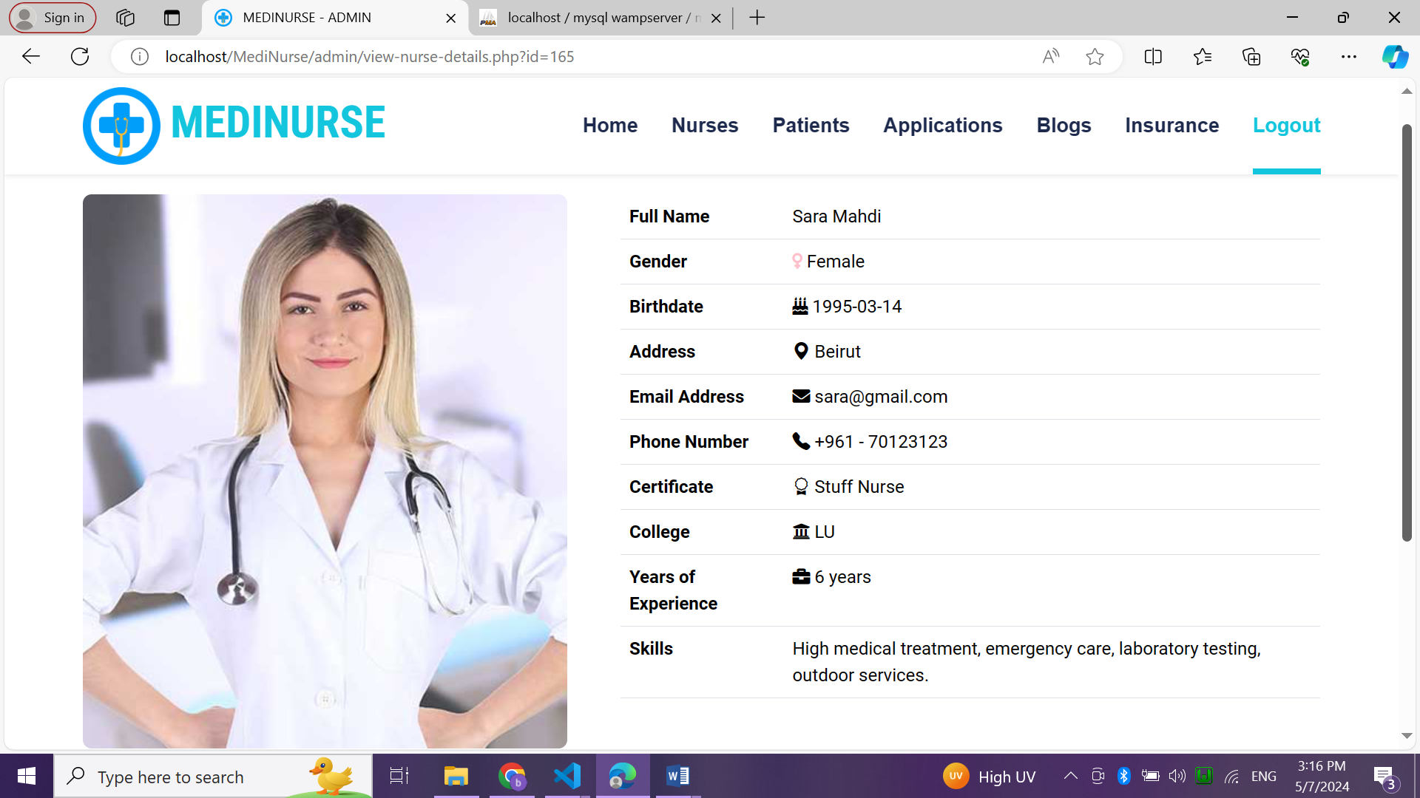

Figure : nurse details page

4.2.8. patients page

This page shows all patients registered in this website with their info.

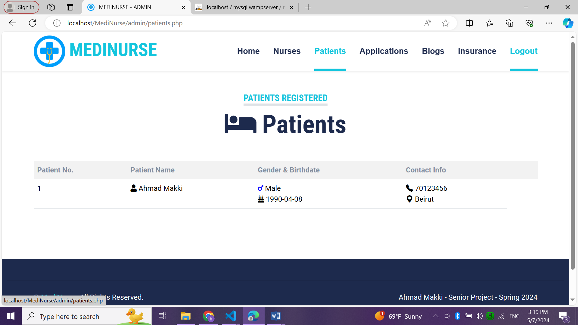

Figure : patients page

4.2.9. upcoming applications page

This page shows all upcoming apps from new nurses with their info and button to see all their info.

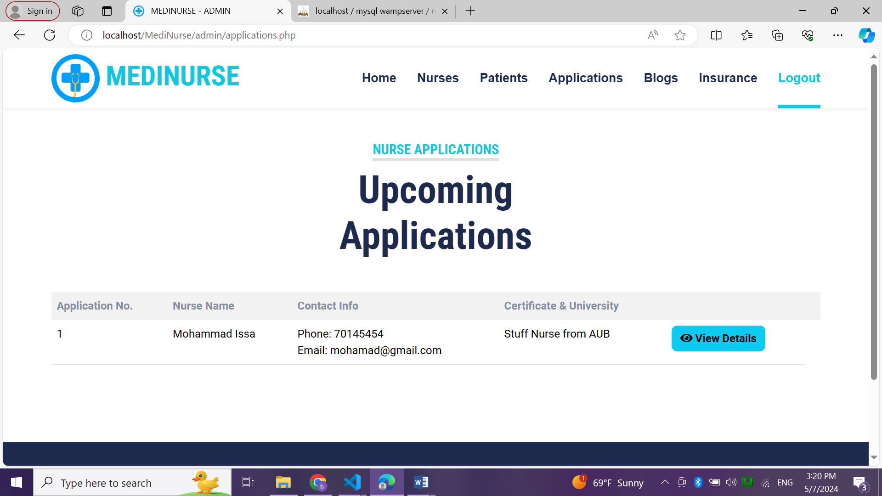

Figure : upcoming applications page

4.2.10. nurse application page

This page shows all details related to a nurse application with his/her profile.

Admin can accept or reject him.

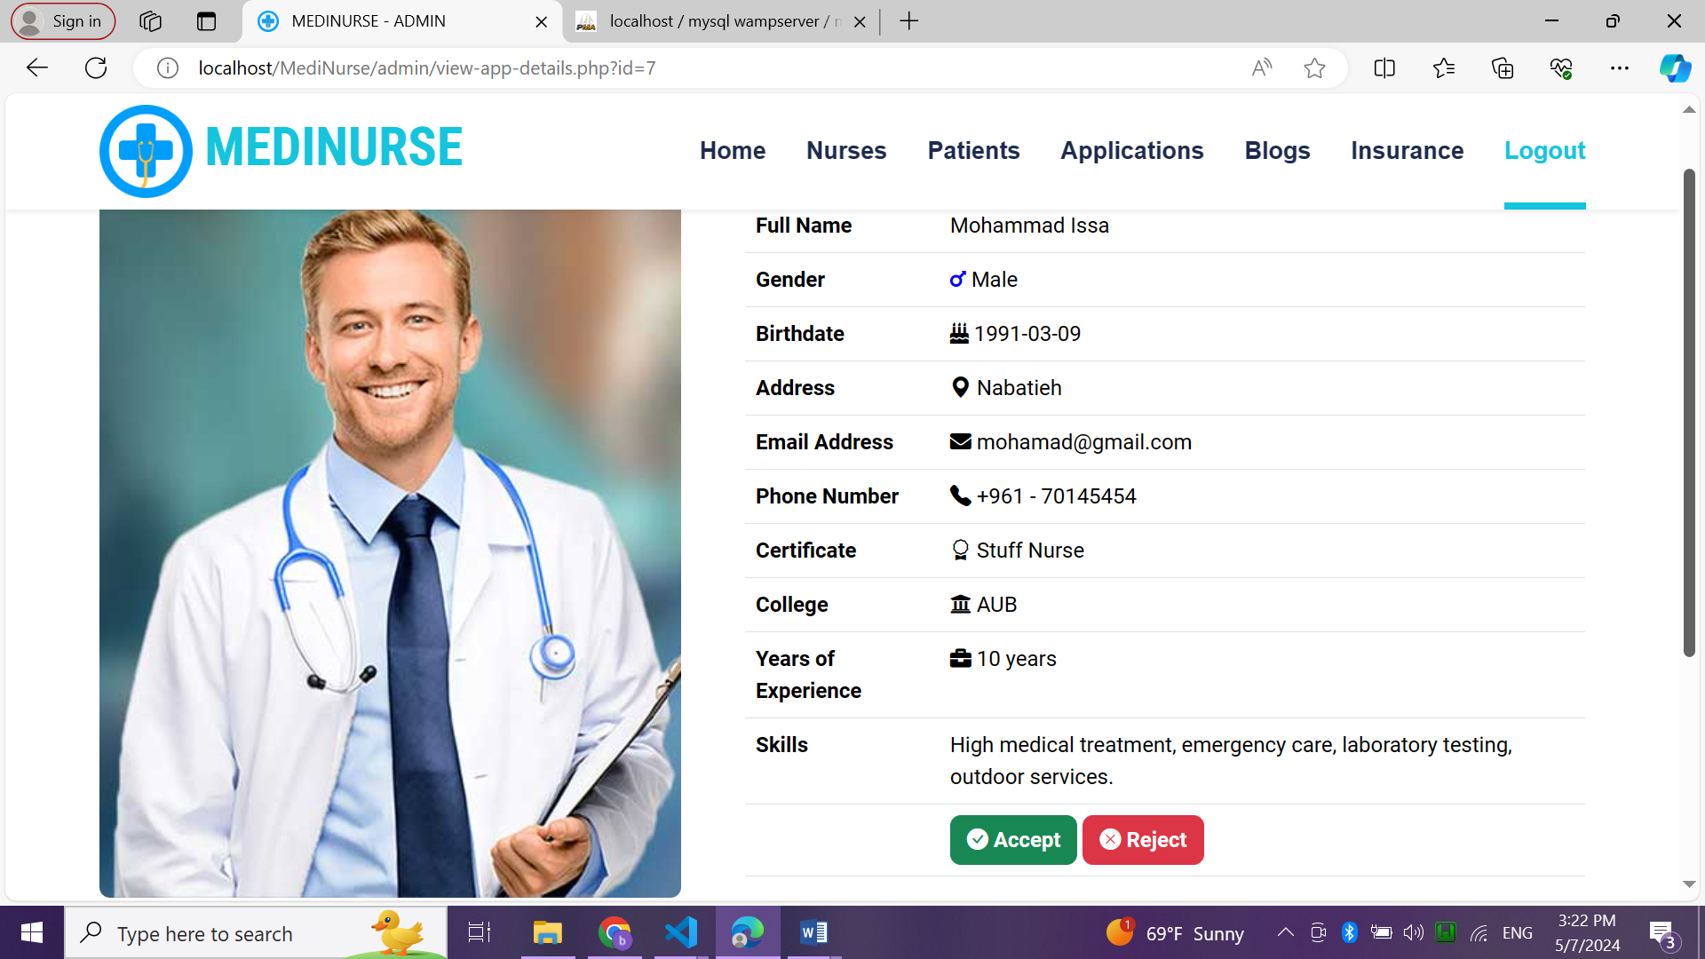

Figure : applications page

4.2.11. blogs page

In this page, admin can add new medical blog and see all published blogs with their details.

He can view each blog, view all comments related to it and delete it.

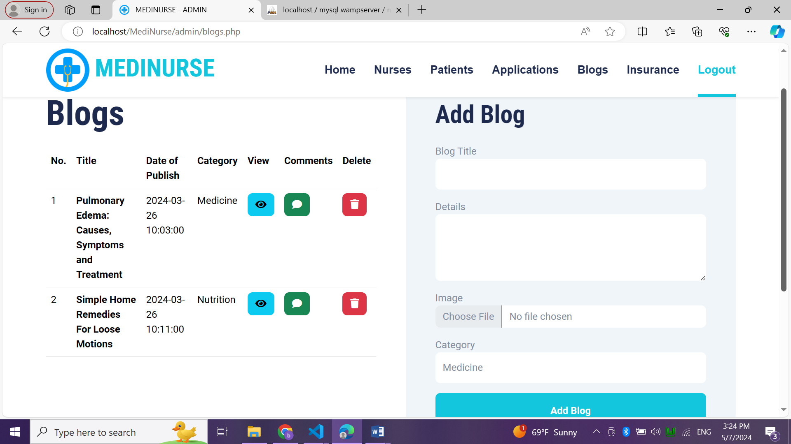

Figure : blogs page

4.2.12. blog details page

This page shows the blog, its image, description, date of publish and category.

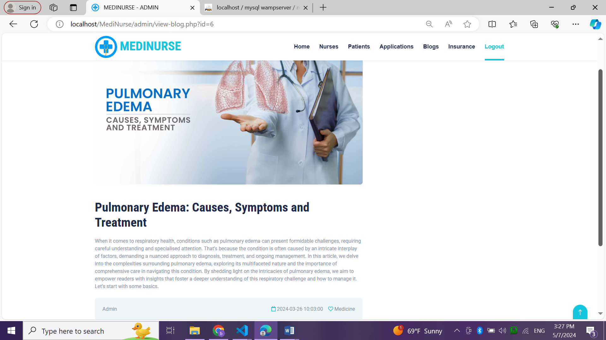

Figure : blog details page

4.2.13. comments page

This page shows all comments for a blog

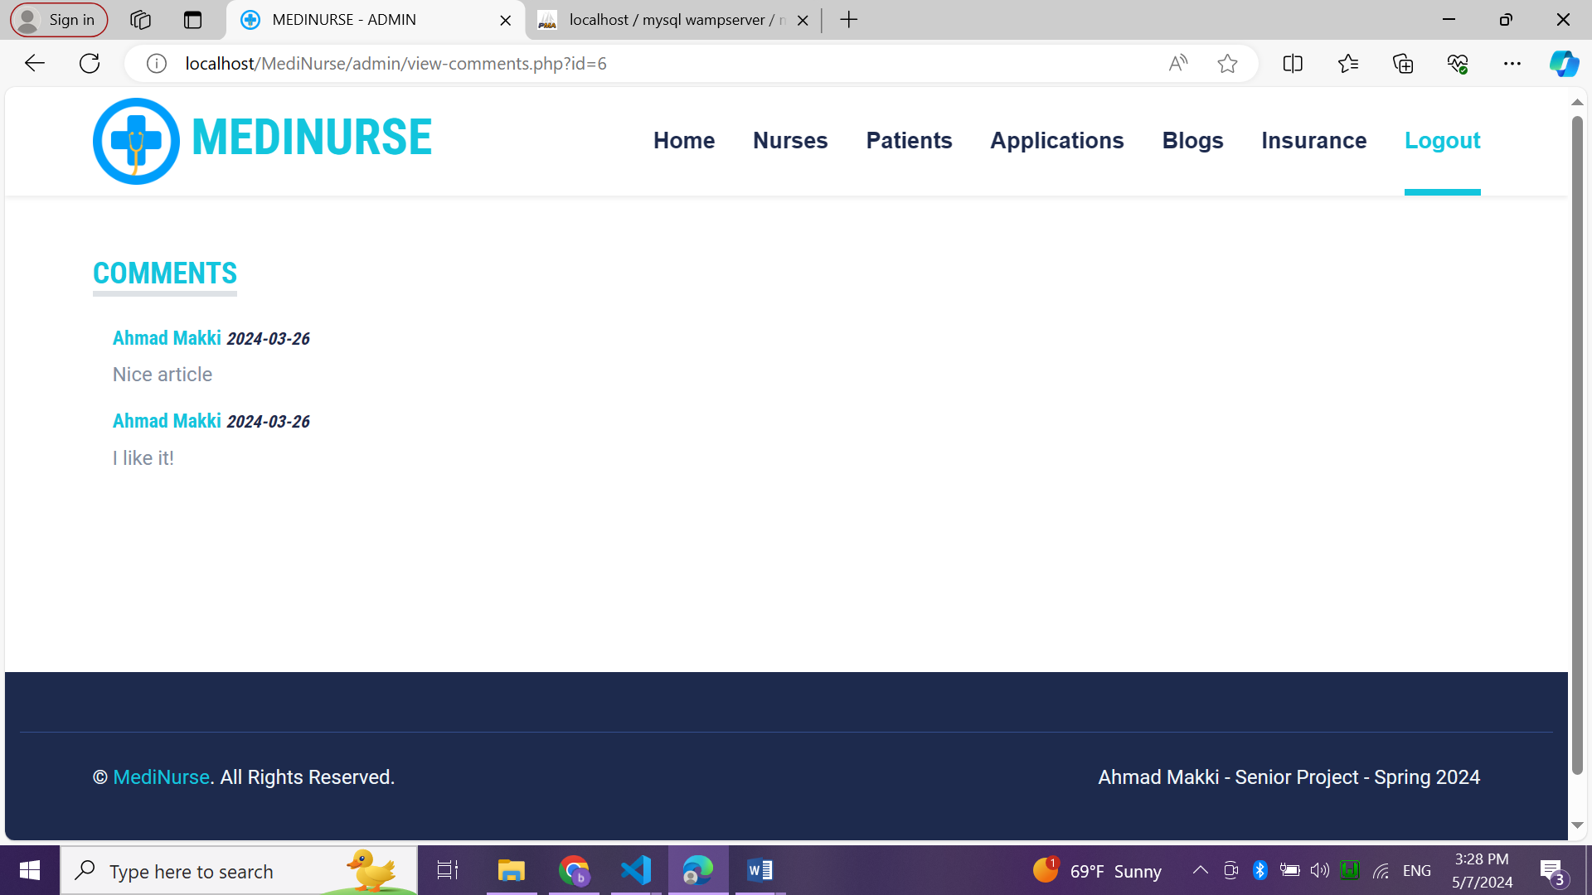

Figure : comments page

4.2.14. insurance plans page

This page shows all saved insurance plans with their prices.

Admin can add new insurance plan.

Admin can view subscribers for each plan, edit and delete it.

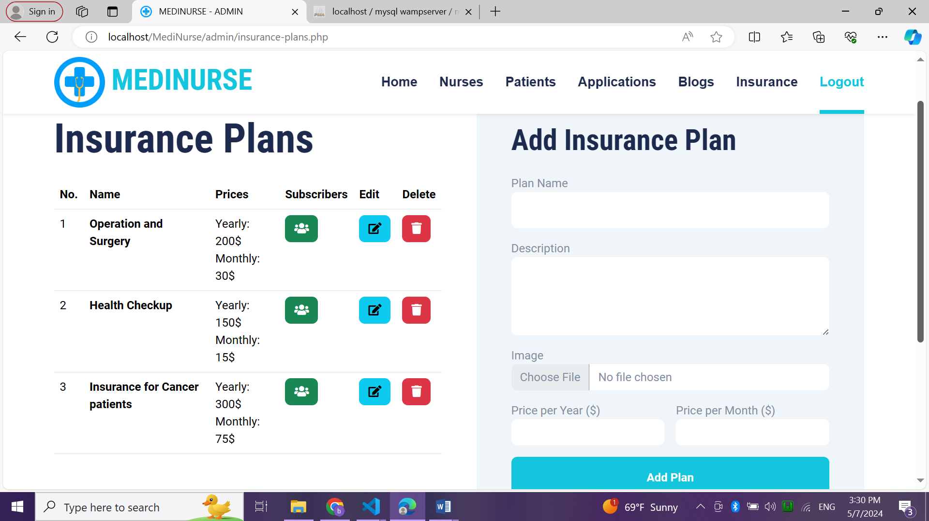

Figure : insurance plans page

4.2.15. subscribers page

This page shows all subscribers of each plan with their info and payment info.

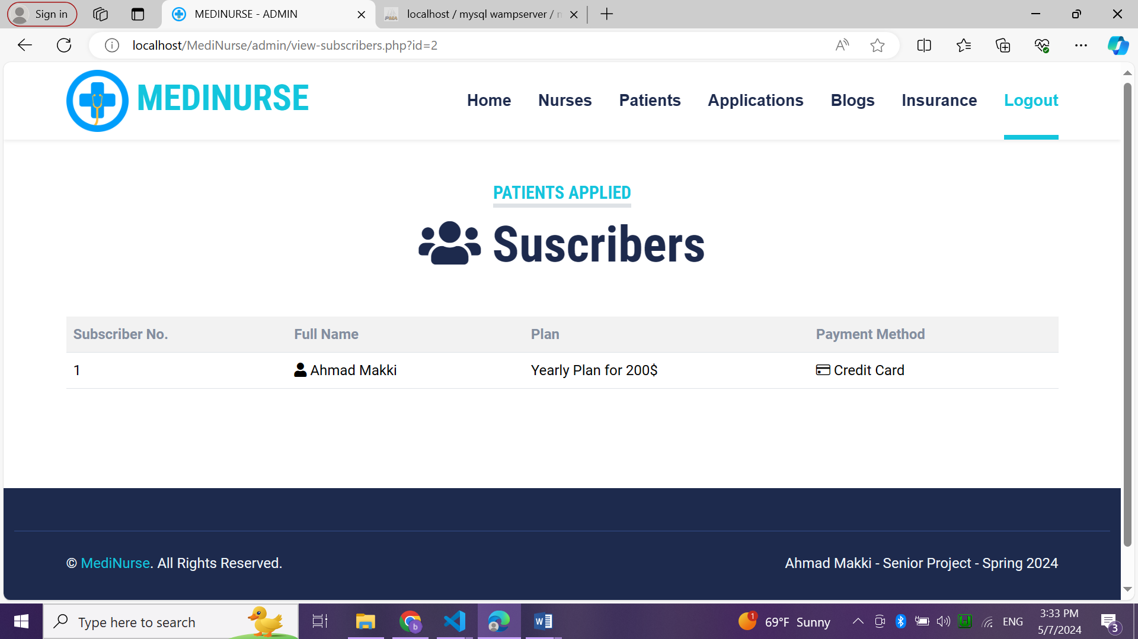

Figure : subscribers page

4.2.16. edit plan page

In this page admin can edit any plan by updating its info.

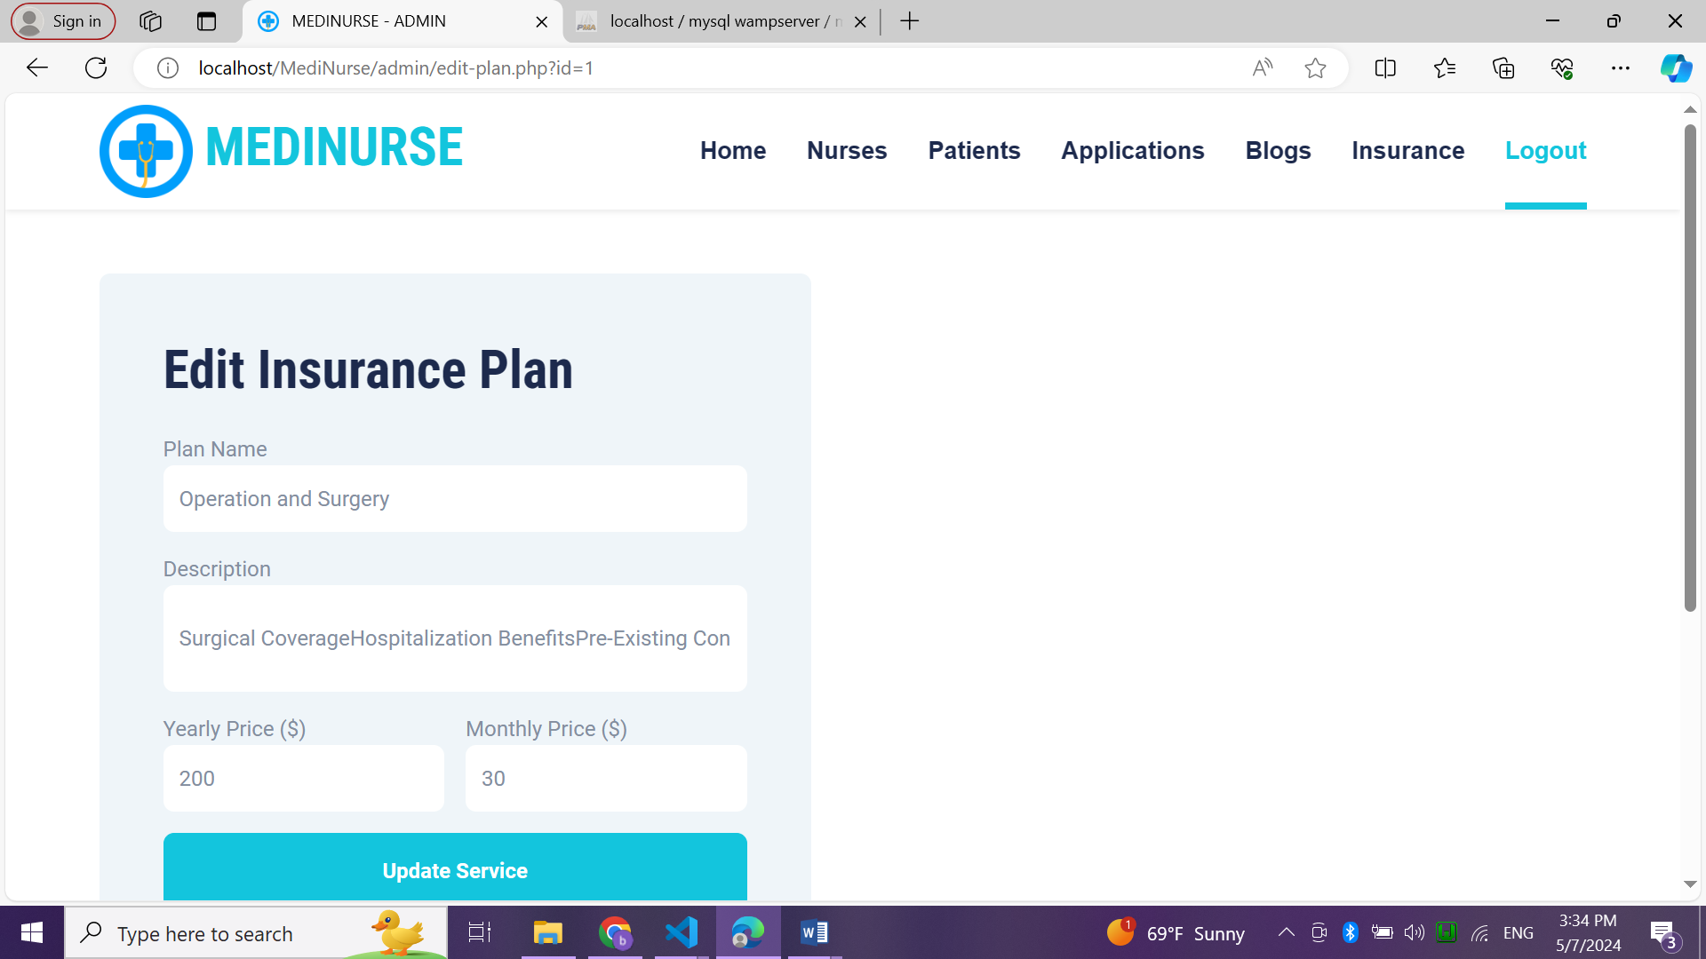

Figure : edit plan page

4.2.17. home page of patient

It’s same as the index page with different menu where patient can find nurses, see all insurance plans, blogs and his requests from nurses and logout.

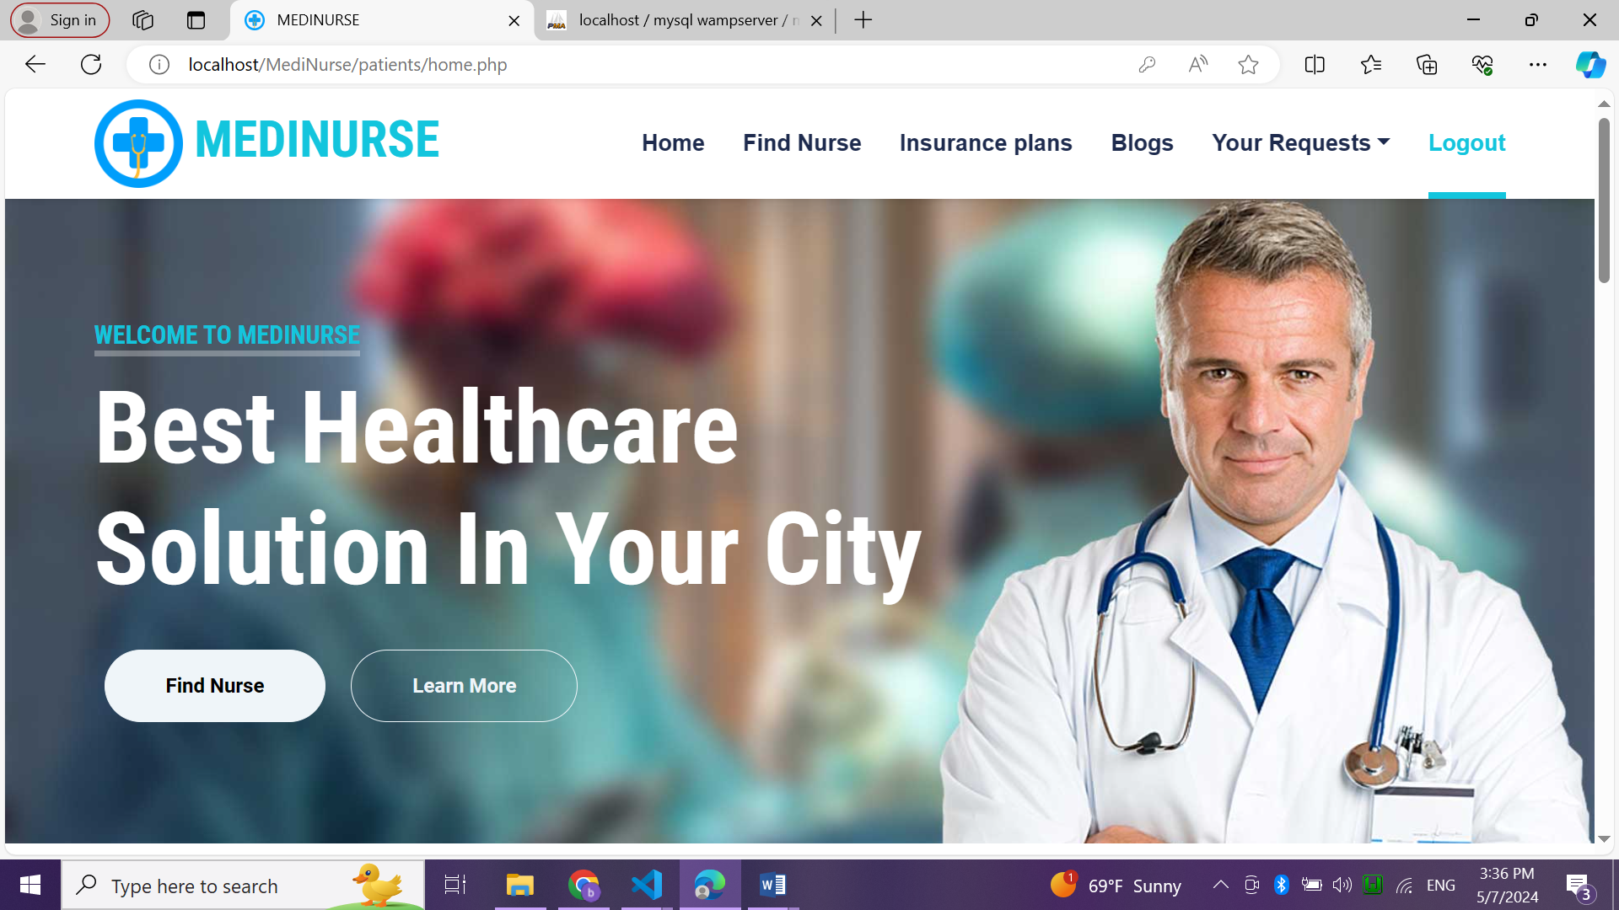

Figure : home page of patients

4.2.18. find nurse page

It shows all nurses joined with their info, phone number and 3 links that are:

* To see all details of each nurse.
* To request service.
* To schedule appointment.\

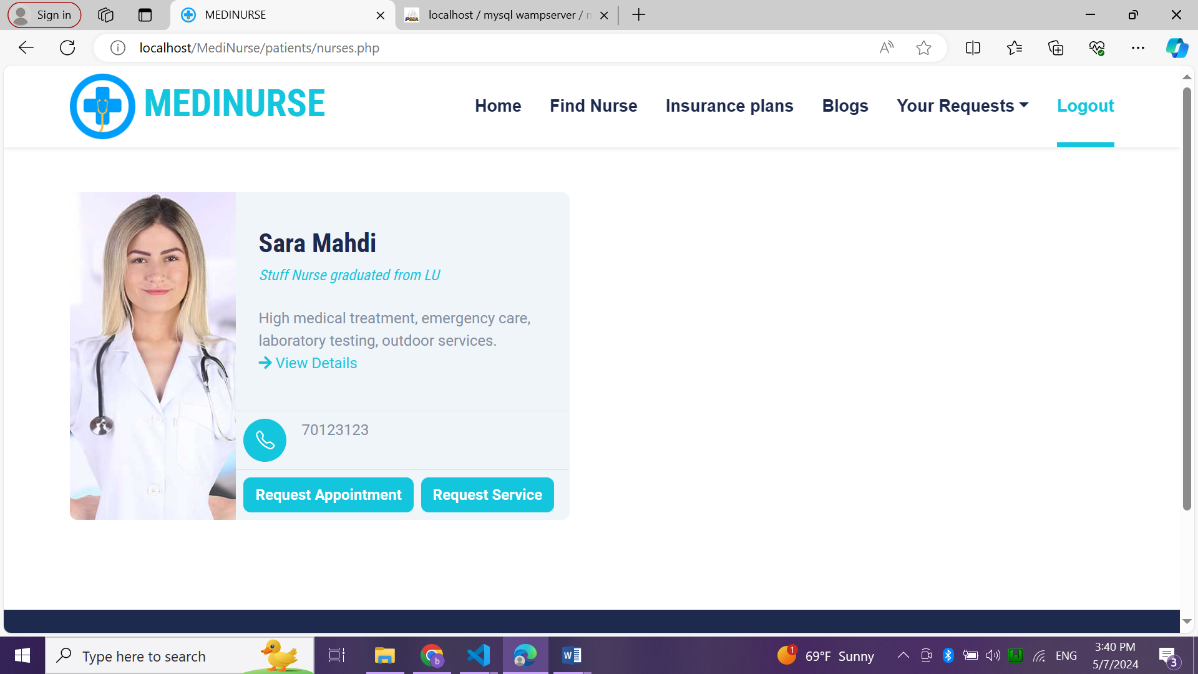

Figure : find nurse page

4.2.19. nurse details page

This shows all information related to a nurse with his image.

It also shows all services offered by this nurse with its price.

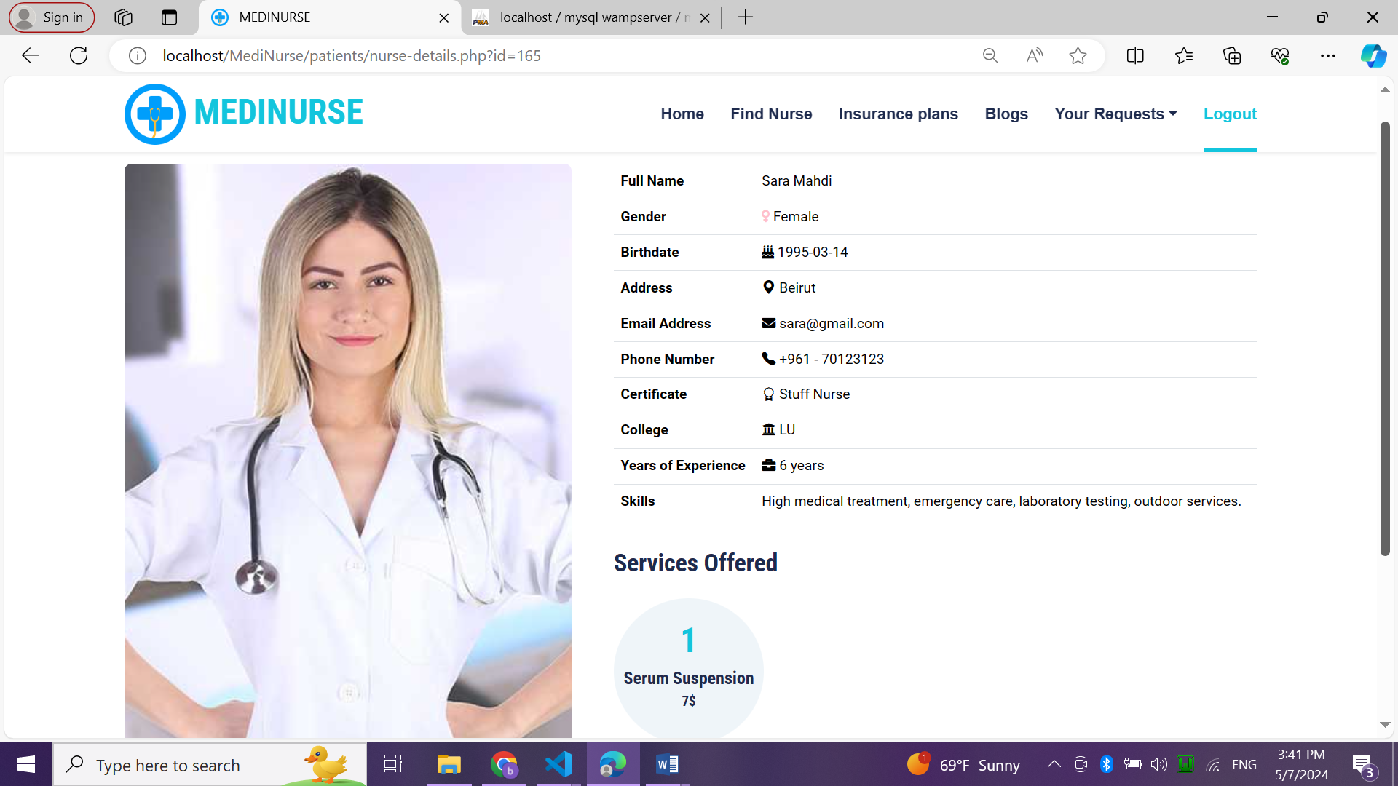

Figure : nurse details page

4.2.20. request appointment page

This page shows all availabilities of this nurse from day and time and price per hour.

There is a form to book an appointment from this nurse by selecting availability, choose date and coming time.

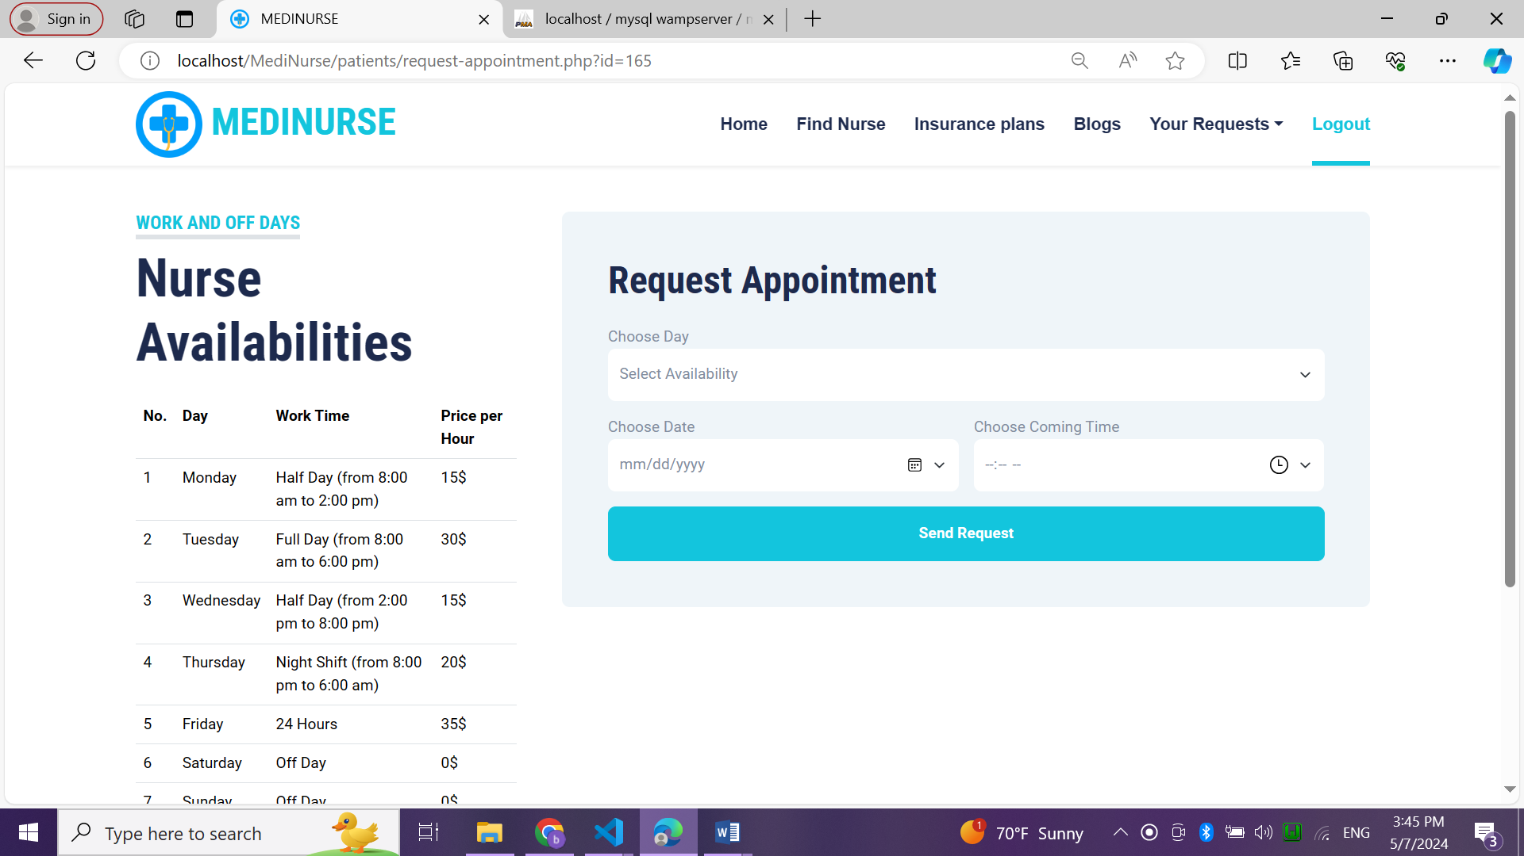

Figure : request appointment page

4.2.21. request service page

This page shows all services offered by this nurse with their details and price.

A form to request service from nurse by selecting service, choosing date and coming time.

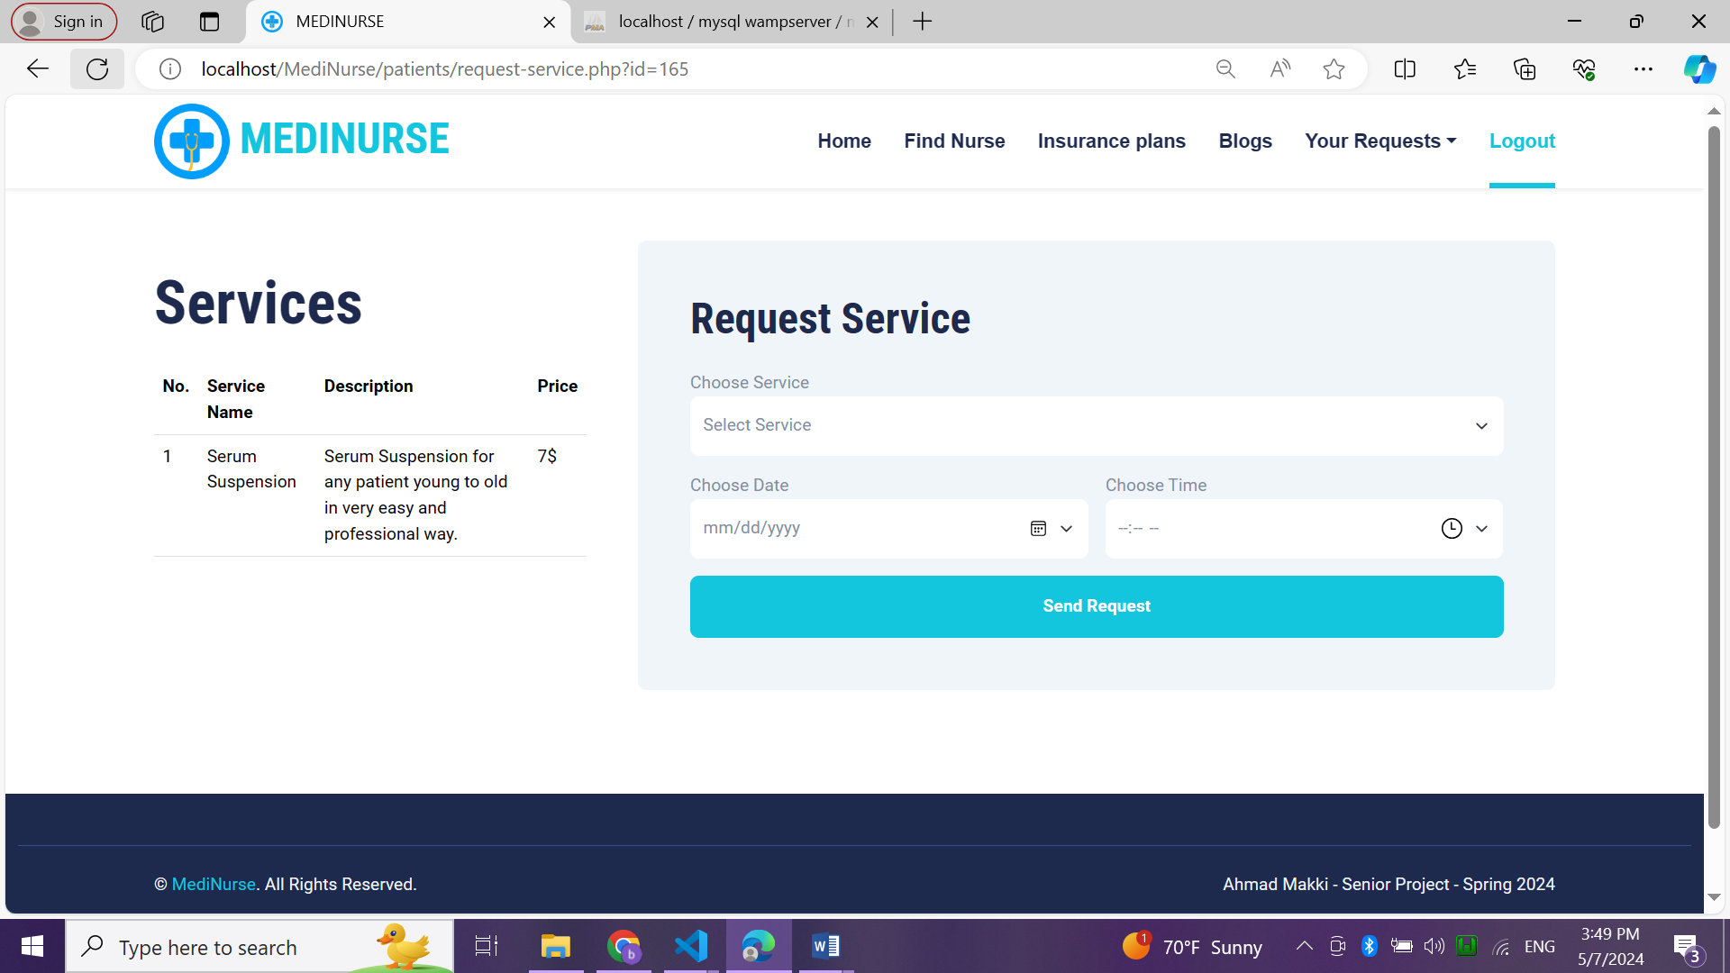

Figure : request service page

4.2.22. insurance plans page

This page shows all insurance plans added by admin with their yearly and monthly prices.

Patient can choose one or more plan and subscribe to it.

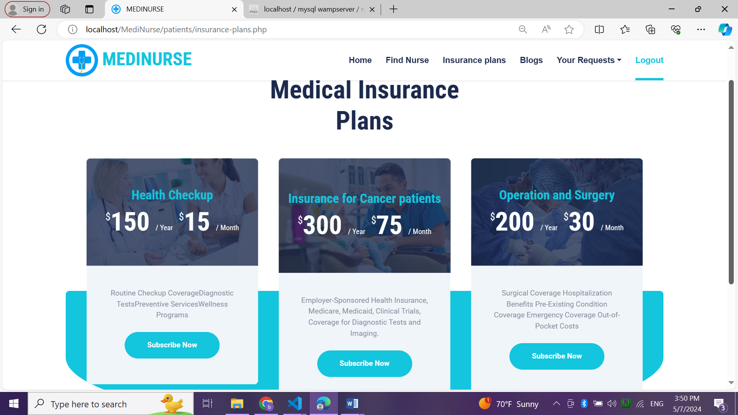

Figure : insurance plan page

4.2.23. insurance plan details page

It shows plan details and form to choose plan method and payment method.

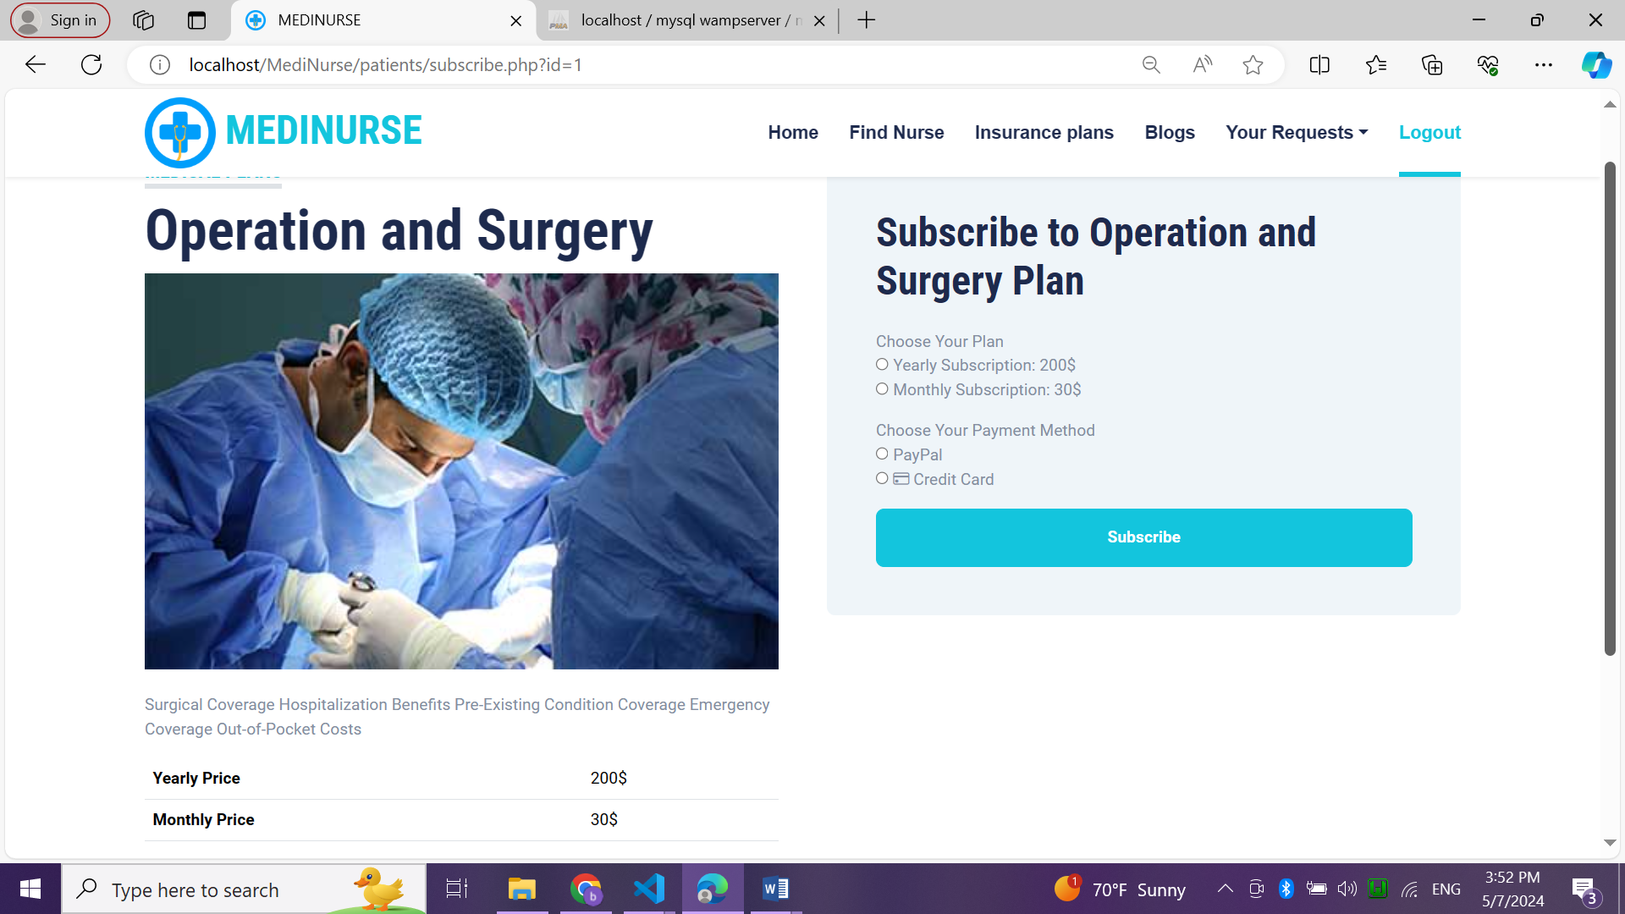

Figure : insurance plan details page

4.2.24. blogs page

This page shows all medical blogs added by admin, their title and comments number.

Patients can read any blog.

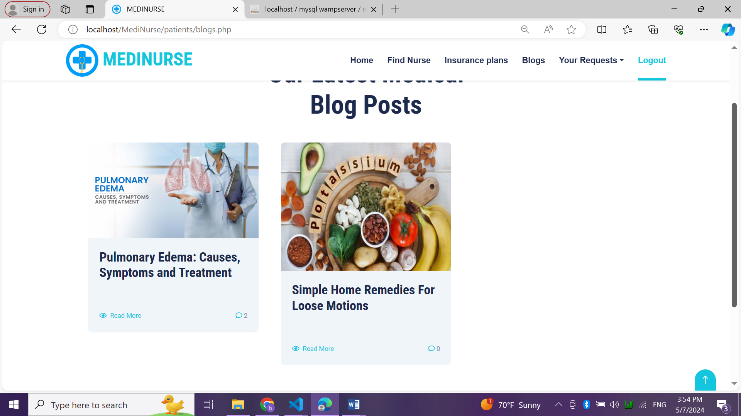

Figure : blogs page

4.2.25. blog details page

This page shows the blogs details, all comments related to this blog and a form that allows to patient to leave his comment.

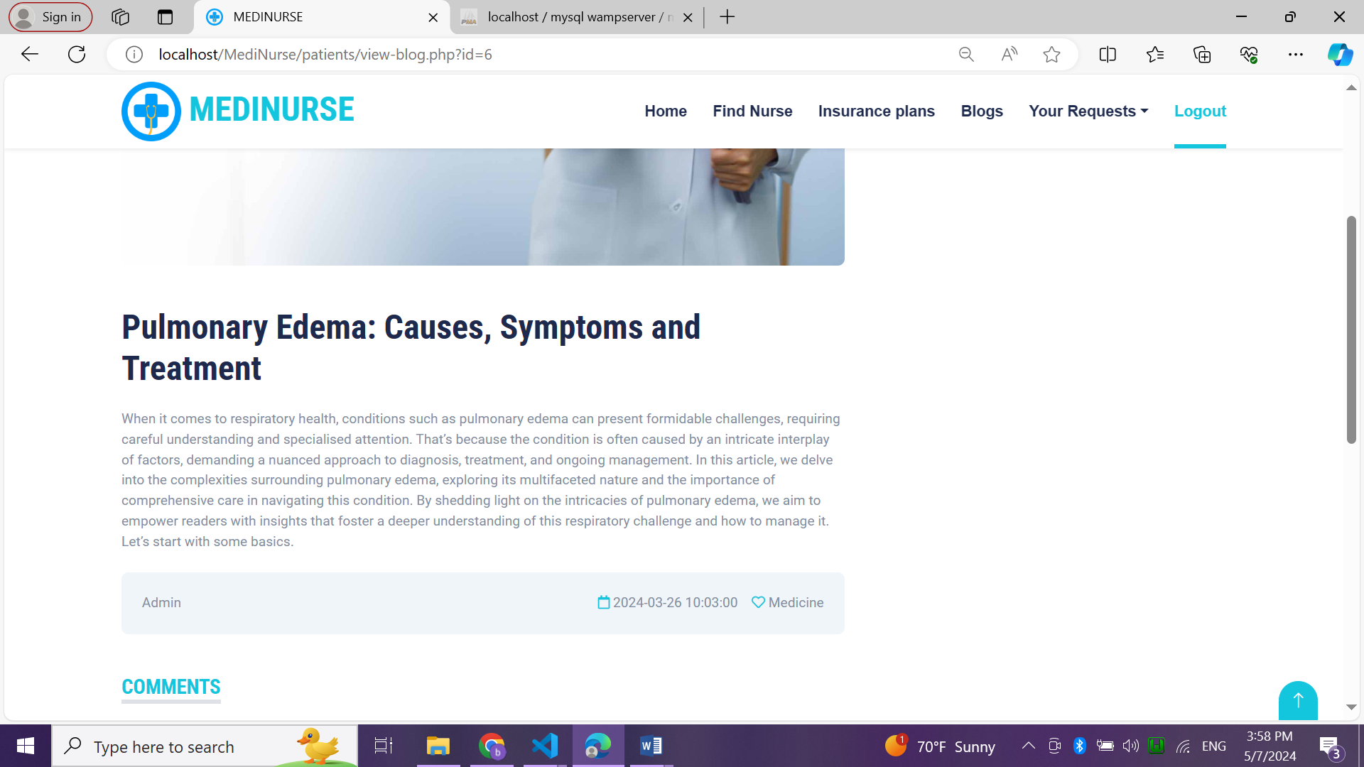

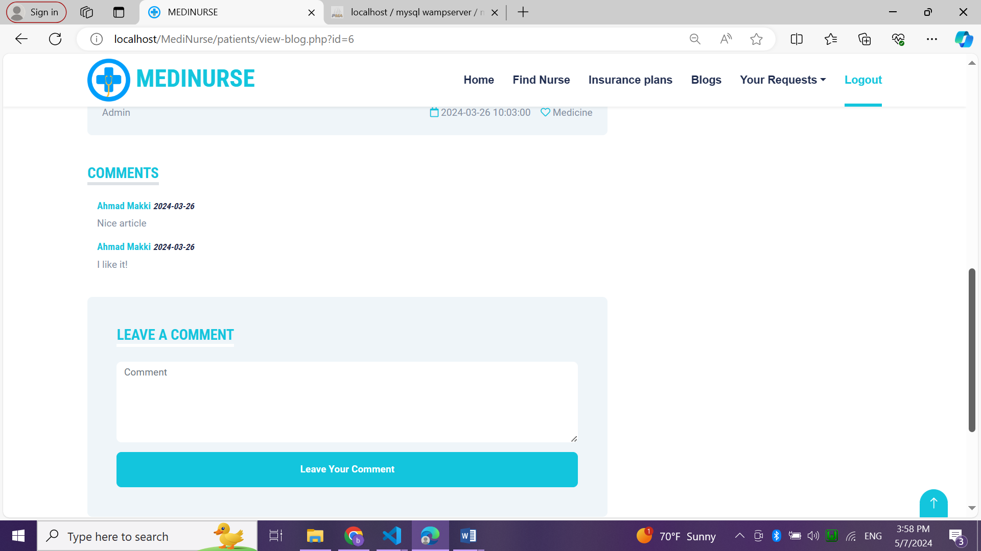

Figure : blog details page

4.2.26. appointment requested page

This page shows all appointments with their details and status requested by a patient.

It shows the total price to pay for each appointment.

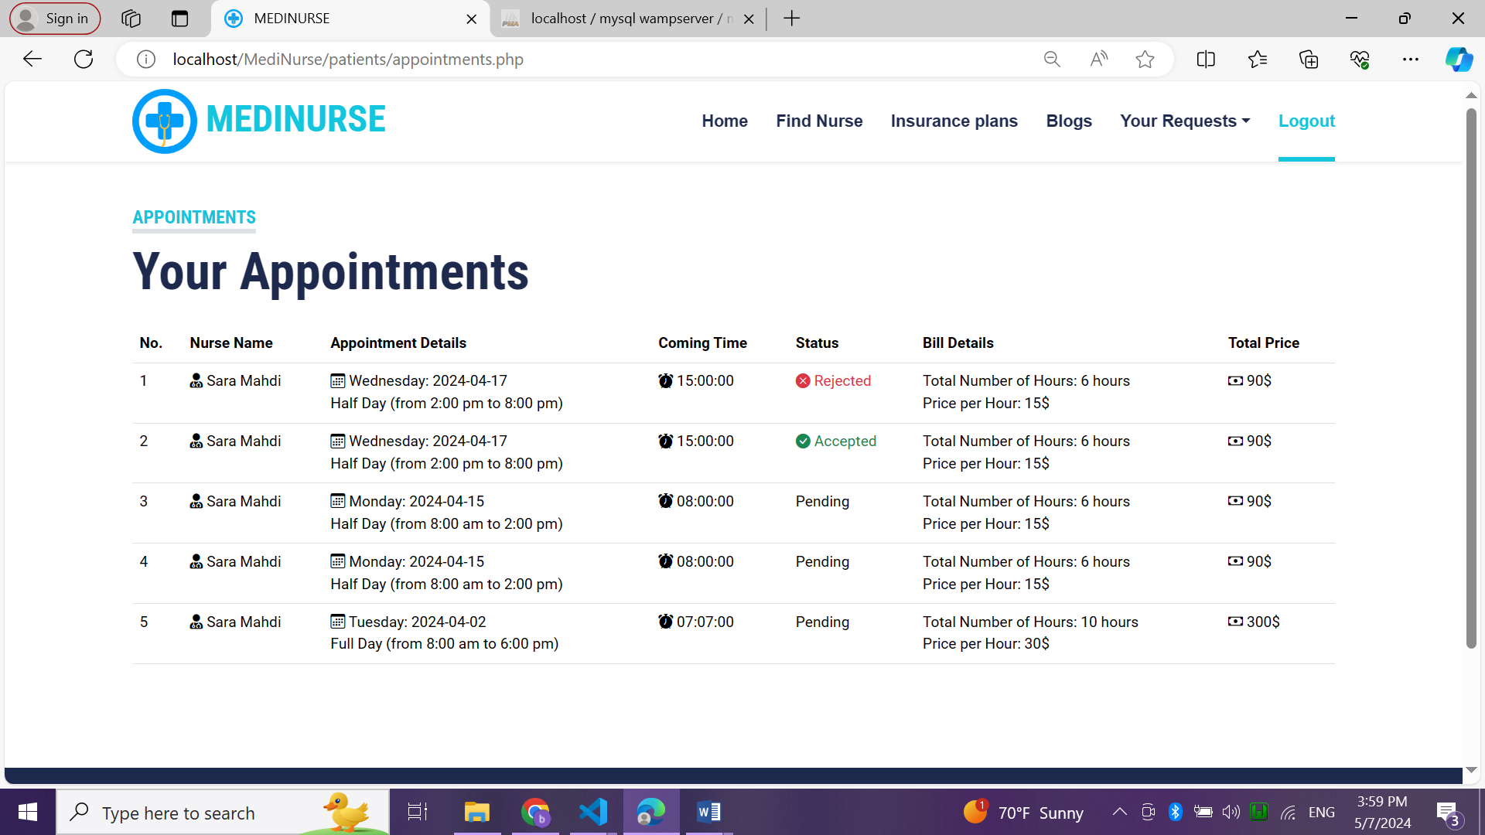

Figure : appointments requested page

4.2.26. services requested page

This page shows all requests for services with their details and status.

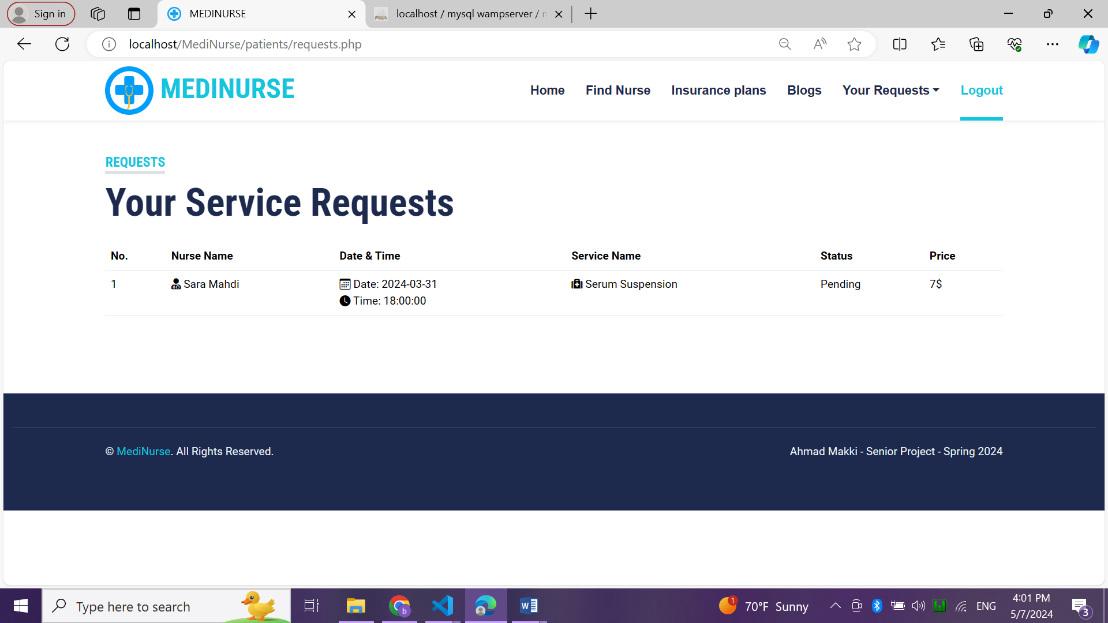

Figure : requested services page

4.2.27. home page of nurse

This is a welcome page for nurse that consists of menu and main background.

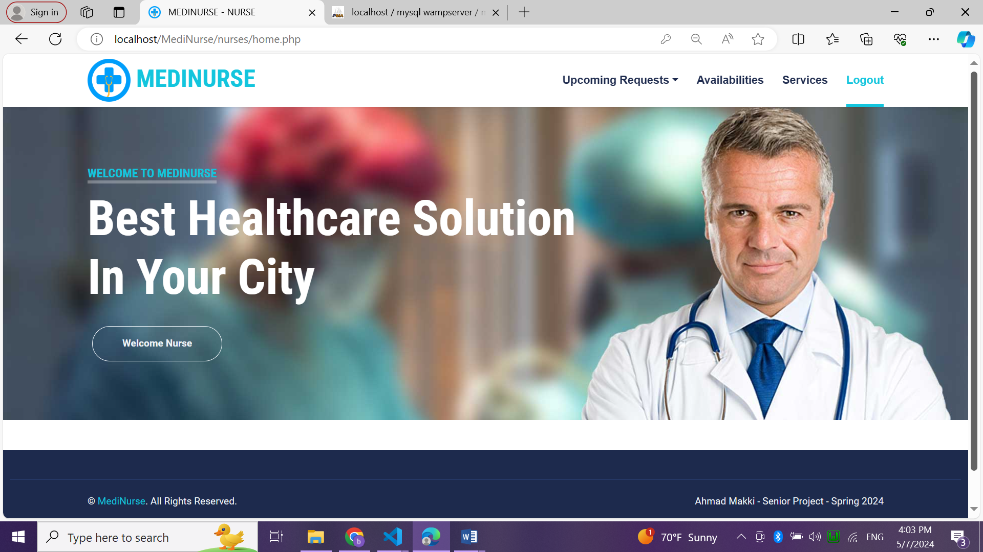

Figure : home page of nurse

4.2.28. upcoming requested appointments page

This page shows all upcoming appointments requested from patients with some details.

Nurse can check all details of each appointment.

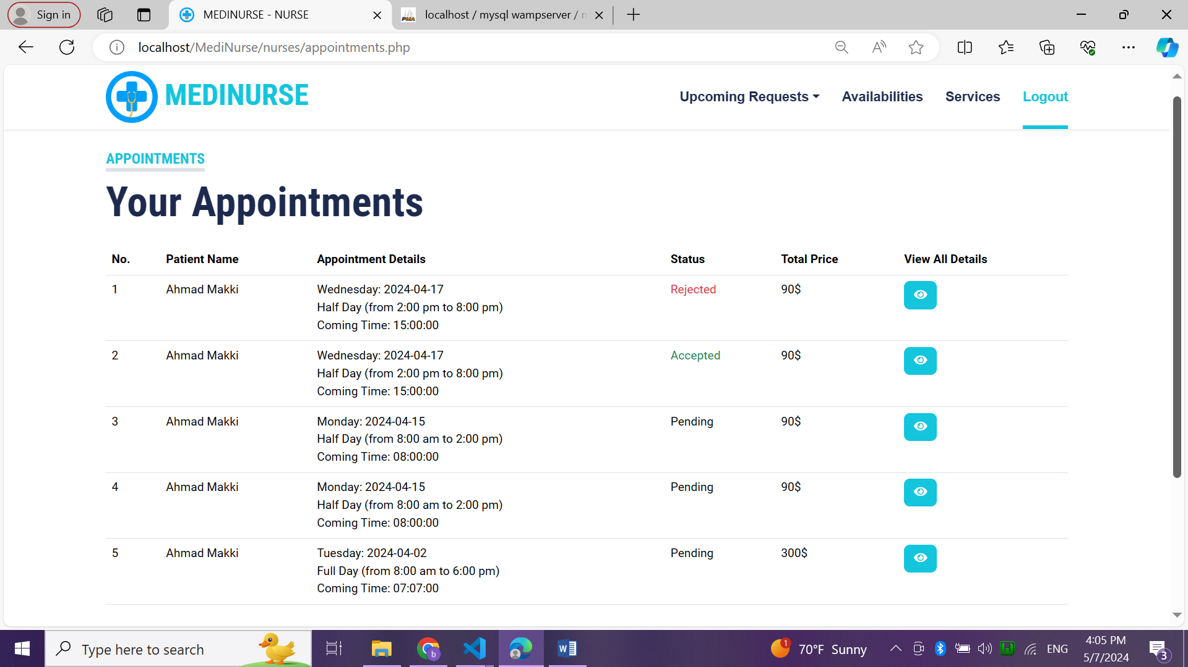

Figure : requested appointments

4.2.28. requested appointment details

This page shows all details related to specific appointment.

Nurse can accept or reject a request.

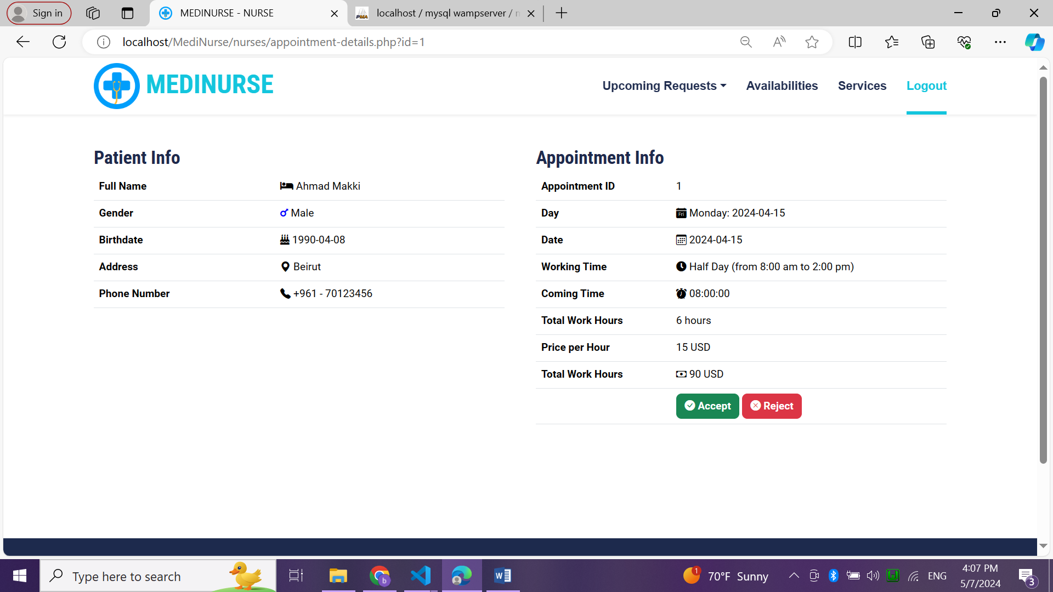

Figure : appointment details

4.2.29. upcoming requested services page

This page shows all requested services from patients with some details.

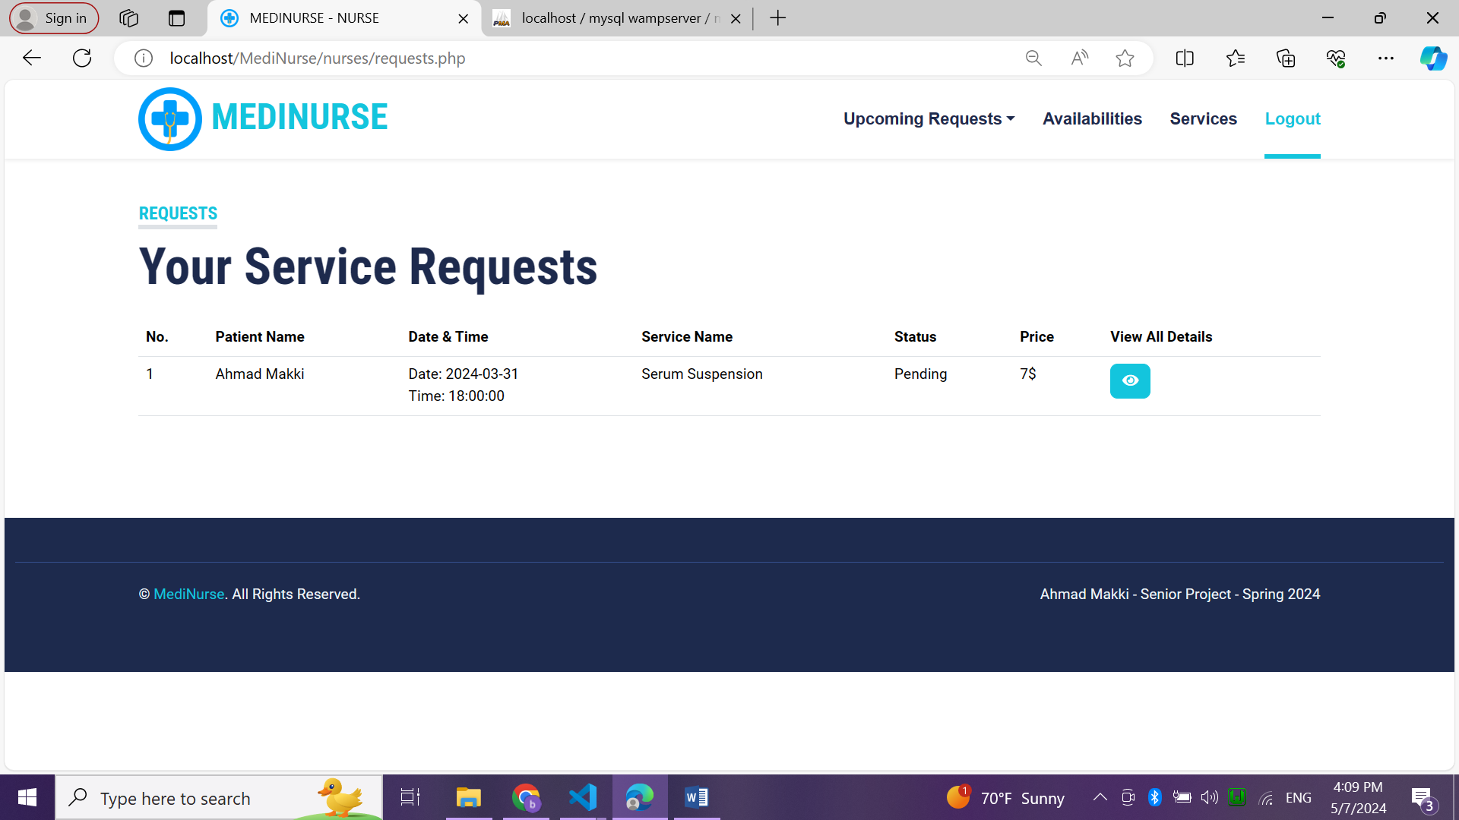

Figure : upcoming requests for services

4.2.30. requested services details

This page shows all details related to a request service with option to accept or reject it.

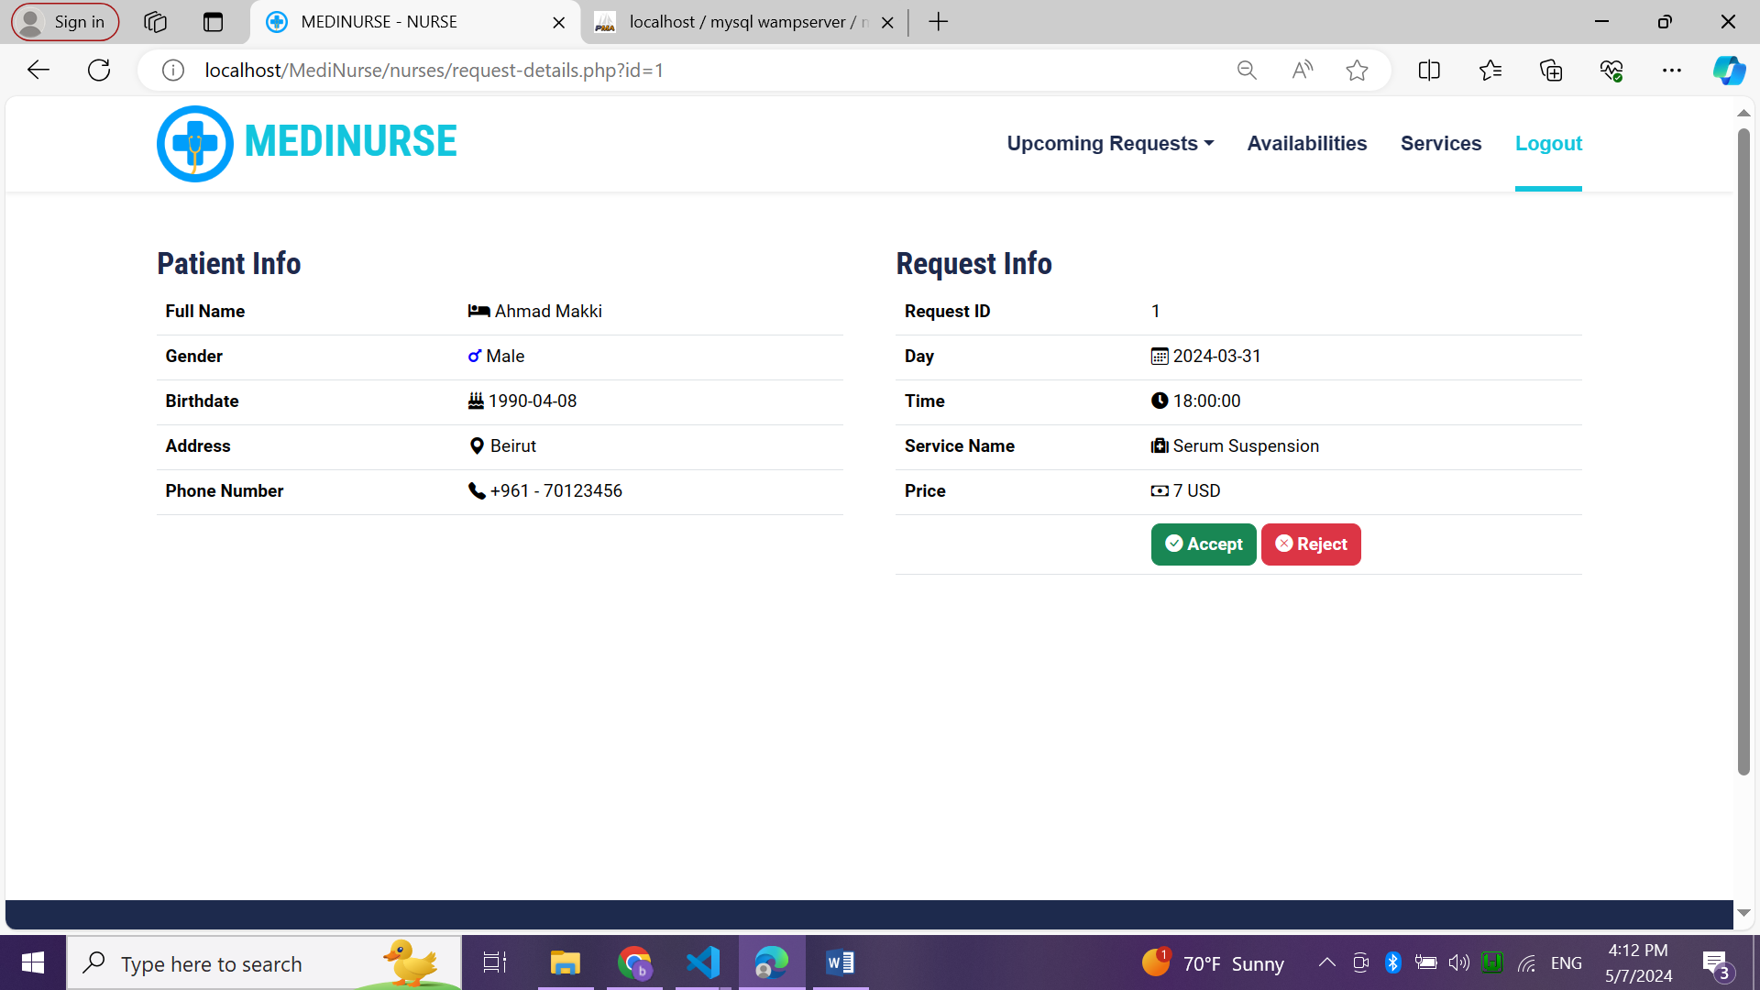

Figure : requested services details

4.2.31. availabilities page

This page shows all availabilities and work hours added by a nurse.

A form to add new availability by choosing day, work time and price per hour.

Nurse can edit or delete any availability.

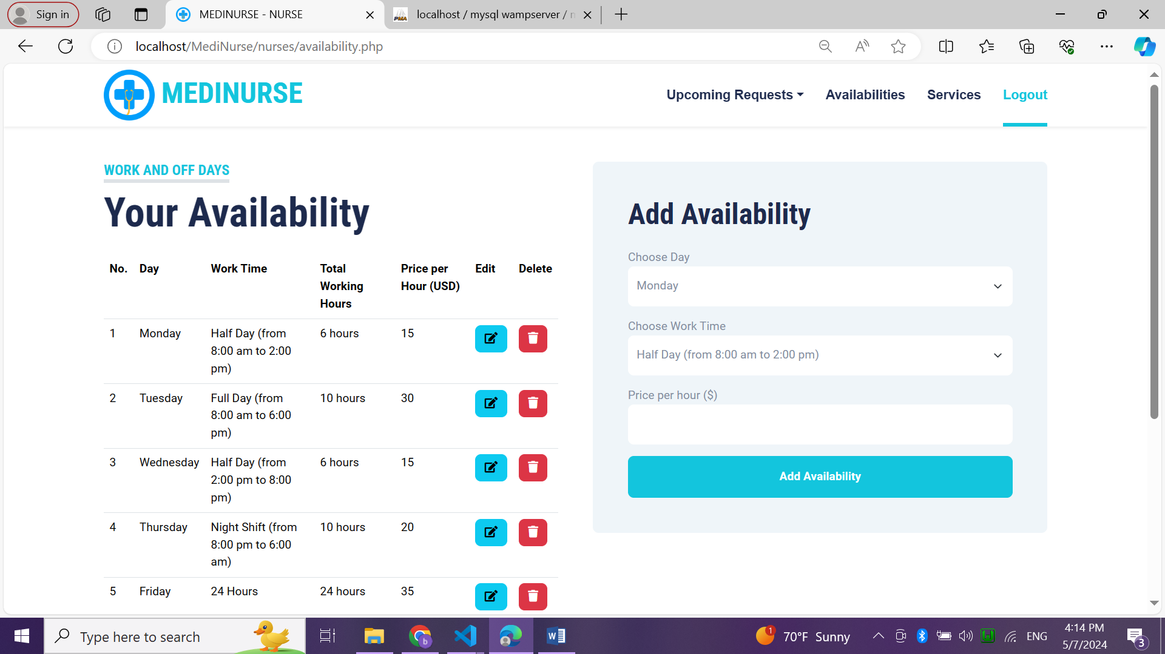

Figure : availabilities page

4.2.32. services page

This page shows all services and their price added by a nurse.

A form to add new service by typing its name, description and price.

Nurse can edit or delete any service.

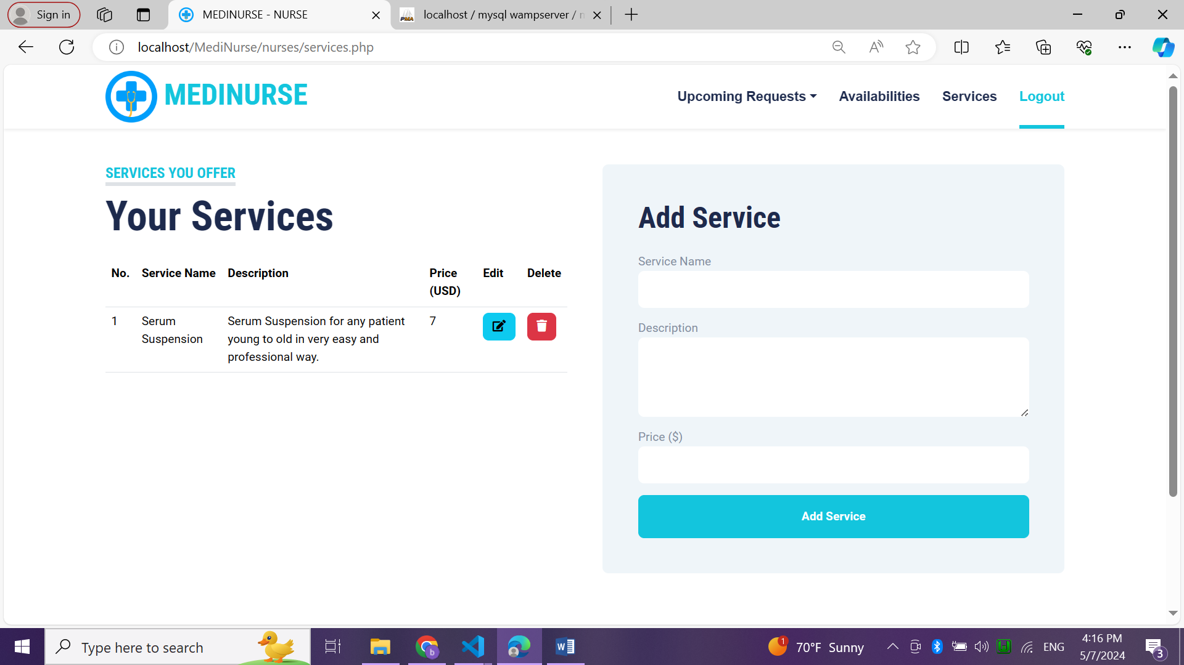

Figure : services page

# Chapter 5

## Conclusion:

In conclusion, the development of a web-based platform connecting patients with private nurses offers significant advantages in improving the accessibility, efficiency, and quality of healthcare services. By addressing the challenges associated with traditional methods of patient-nurse communication and appointment scheduling, the platform enhances patient satisfaction, promotes proactive health management, and optimizes resource utilization within the healthcare ecosystem.

## Future Work:

Future work for the platform includes integrating telemedicine capabilities for remote consultations, enhancing personalization through advanced algorithms, expanding services to include additional healthcare professionals beyond nursing, developing a mobile application for increased accessibility, integrating wearable health monitoring devices, exploring geographical expansion opportunities, and investing in research and innovation to leverage emerging technologies such as artificial intelligence and predictive analytics. These initiatives aim to further optimize healthcare delivery, improve patient outcomes, and ensure the platform remains at the forefront of innovation in the evolving landscape of digital healthcare.

# References

|  |  |
| --- | --- |
| [1] | [Online]. Available: https://onlinelibrary.wiley.com/doi/10.1111/j.1365-2702.2004.00817.x. |
| [2] | [Online]. Available: https://www.researchgate.net/publication/339215620_Communication_in_nurse-patient_interaction_in_healthcare_settings_in_sub-Saharan_Africa_A_scoping_review. |
| [3] | [Online]. Available: https://www.sciencedirect.com/science/article/pii/S2214139119301805. |
| [4] | [Online]. Available: https://scaledagileframework.com/nonfunctional-requirements/. |
| [5] | [Online]. Available: https://app.diagrams.net/. |